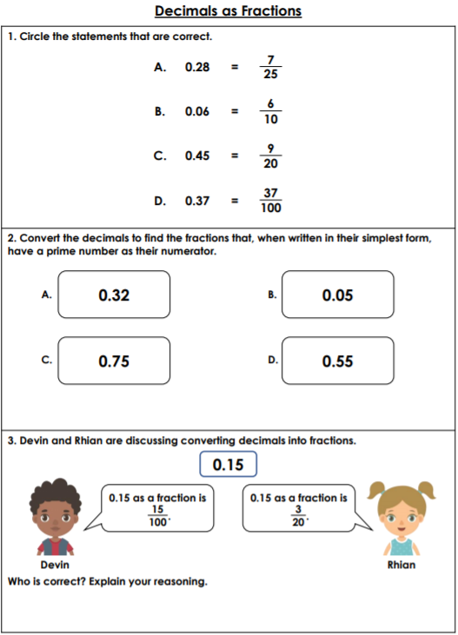

<https://whiterosemaths.com/homelearning/year-6/>

**Drag the circles on the left.**









