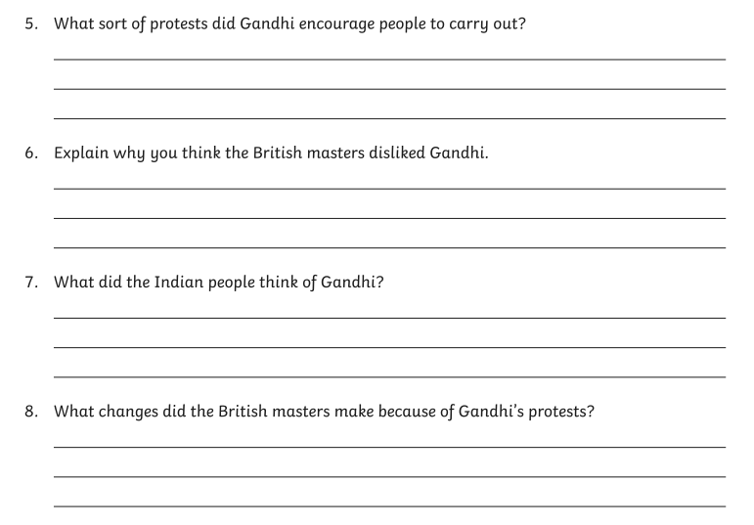Week 7: Tuesday questions for green group