**Art – lesson 5**

This week, as part of our science topic of light, your art/D&T is to create your own periscope.

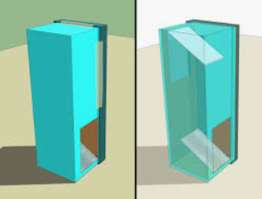

You can use the template and you will need some mirrors, or other reflective materials.

Mirrors from make-up compacts work well. If you don’t have mirrors, you could use anything that reflects well – cellophane, the metallic lids from some takeaways, or even an old CD.

<https://www.youtube.com/watch?v=atfCcPHi6X0>

<https://www.youtube.com/watch?v=Y_7Dg-OeKXg>

If you don’t have a printer to print the template, don’t worry. There are other ideas. You can use almost any cylindrical or cuboid container as the basis for your periscope, eg. A juice carton:

<https://www.youtube.com/watch?v=F_A9hKEmuvk>

When you’ve created your periscope, take photos of it and upload them to j2e so I can see how well you’ve done!