What is capacity?
Capacity is the total amount of liquid that can be contained in a container. It is the word we use when we are measuring liquids.
When we measure liquids we measure in Litres (l) or Millilitres (ml) and need to use a measuring jug or cylinder.
Here are some key words when we think about capacity.
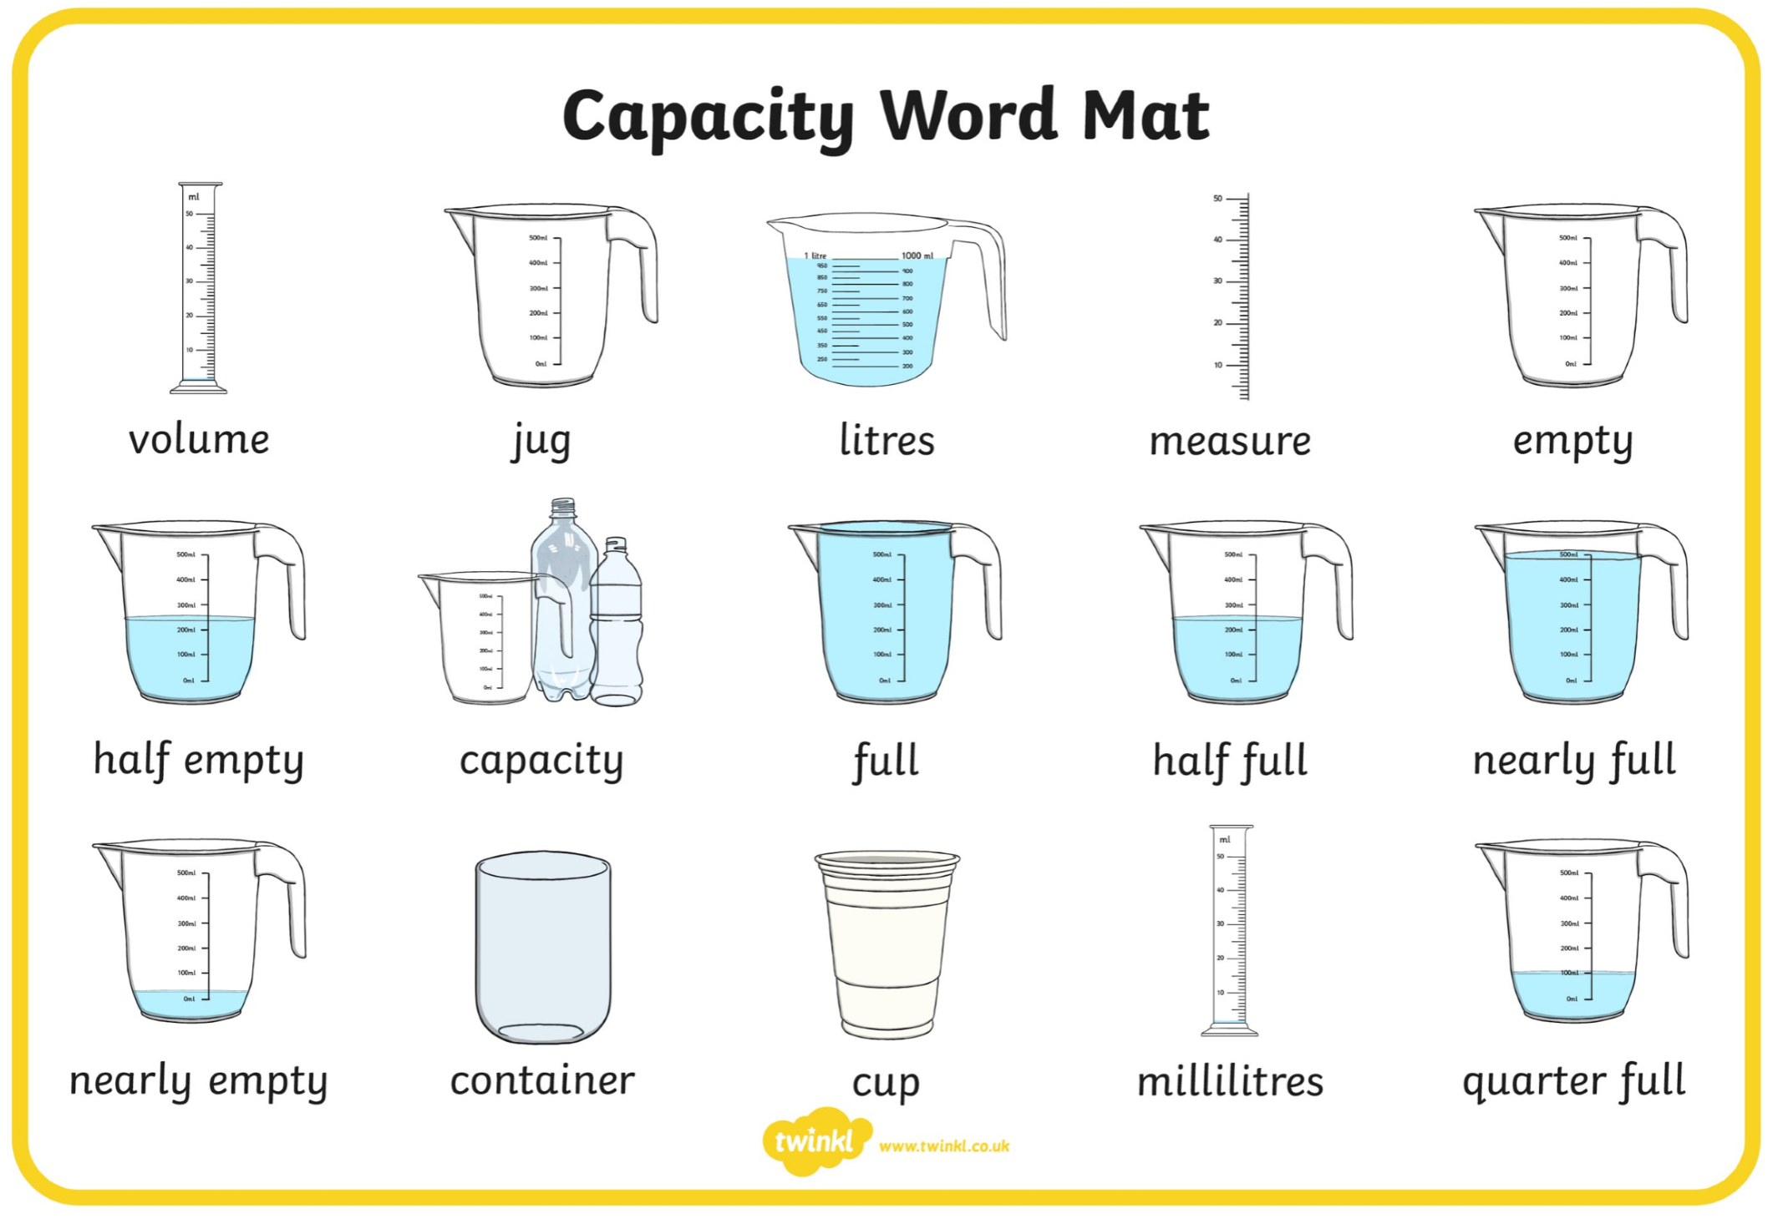
Can you find out any more information about capacity. Maybe research on the internet and see what you can find out.

