Science – lesson 5

This week we’re learning about periscopes.

Watch the video <https://www.youtube.com/watch?v=prxP0rNmaSA>

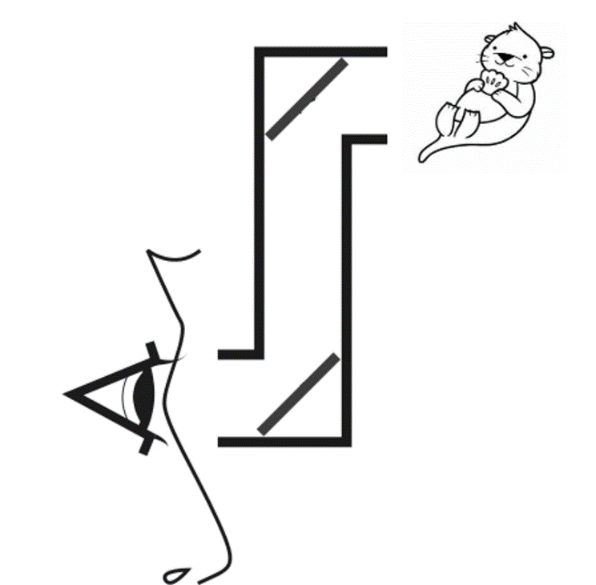Can you draw arrows to show how the light travels and allows the person to see the baby otter? (if you go to the insert tab, and insert shapes, you can choose an arrow)

