**Spanish – lesson 3**

Practice the numbers 1 to 20 using this video on youtube, called Numbers 1-20 in Spanish, by SpanishBasics

<https://www.youtube.com/watch?v=zpLQSdu4V94>

<https://www.youtube.com/watch?v=ZiNFXntWOJw>

Can you colour the crayons in the correct colour?



gris



amarillo



rosa



azul



rojo



naranja



blanco



morado



café



negro



verde

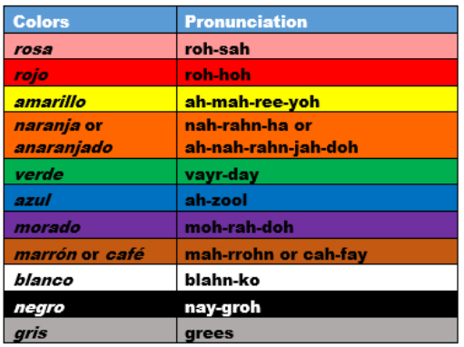

amarillo