**Monday**

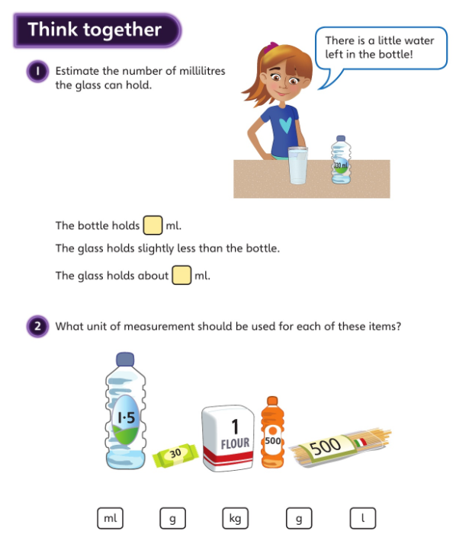

300 ml

300 ml

**Metric measures worksheet:**

4. A. 500m

B. 8.5cm

c. 2 ¼ km

5. Volume – D

Distance – B, C and E

Length - A

6. She cannot measure the distance in kg, as that is used to measure mass. It would be acceptable to measure the distance in either m or km.

**Tuesday**

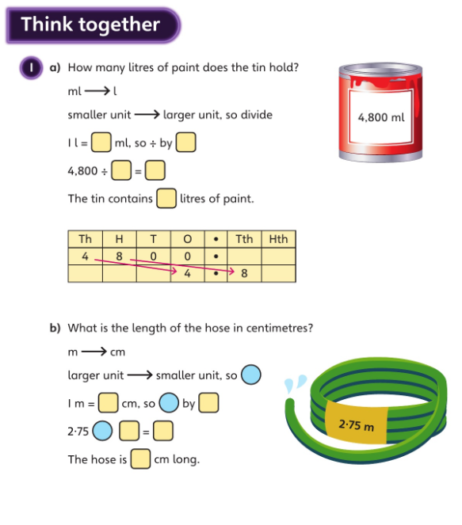

**1L = _1000_ml so we need to divide by _1000_**

**4800 ÷ 1000 = 4.8**

**4.8 L**

**x**

**100**

**x**

**100cm**

**2.75 x 100 = 275**

**275cm**

**Convert metric measures worksheet:**

4. A, B, D, E, F

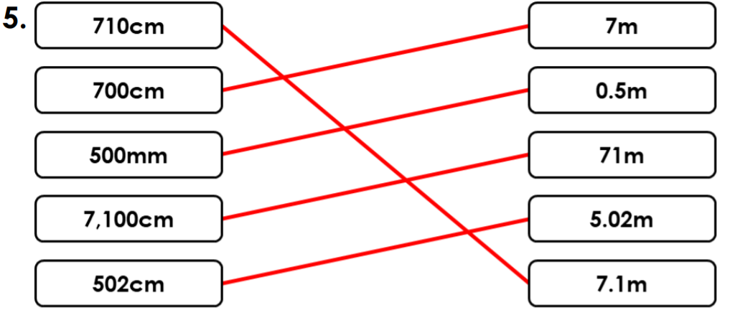

**6.** Aelin is correct because ot convert L to ml you have to multiply by 1000. 3.657 x 1000 = 3657

**Wednesday**

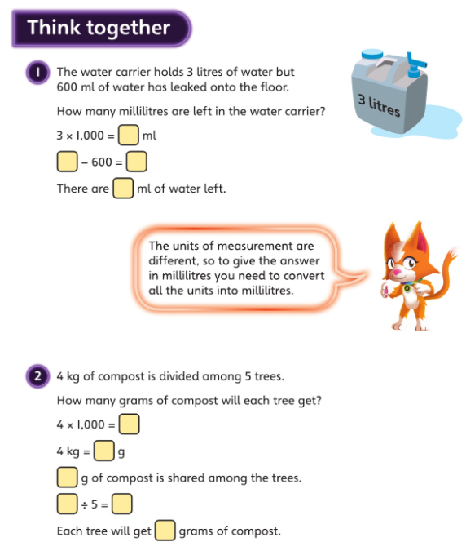

**800**

**4000 ÷ 5 = 800**

**4000gg**

**4000g**

**4000**

**2400ml**

**3000 - 600 = 2400**

**3000ml**

**Problem solving metric measures worksheet:**

**4. A = 0.73m**

**B = 22.75m**

**C = 1.49m**

**D = 20m**

**5. D = 1080g, whereas A, B and C = 1224g**

**6. Jenna is incorrect. When converting her answer to litres, she has divided by 100 instead of 1000. The correct answer is 6.18L**

**Thursday**

**Think Together :**

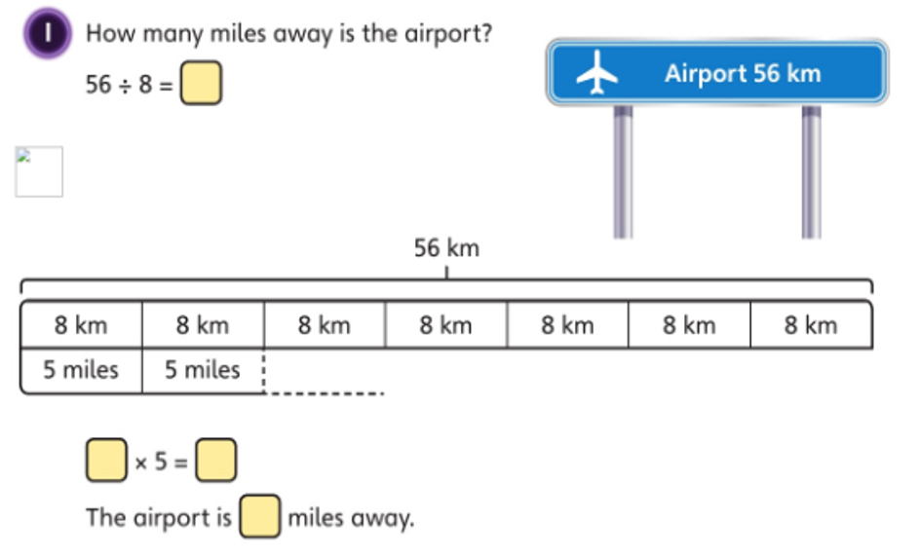

35

35

7

7

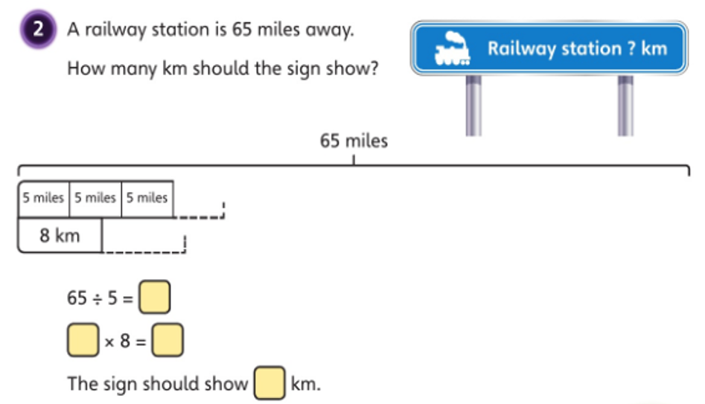

104km

104

13

13

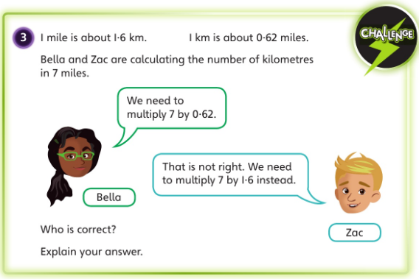

Zac is correct because there are 1.6km in 1 mile. That means that there will be 1.6 times as many km as miles in any distance.

7 x 1.6 = 11.2km, while 7 x 0.62 = 4.34km. As Km are smaller than miles, there will be more km than miles in any distance.

**Miles and Kilometers worksheet:**

1. 15 miles < 32km

16km < 20 miles

48km = 30 miles

45 miles > 64km

1. A. 10 miles

B. 56km

C. 40 miles

1. No, because three school weeks is 15 days and after this time Ashleigh will have walked 120km which is 75 miles.

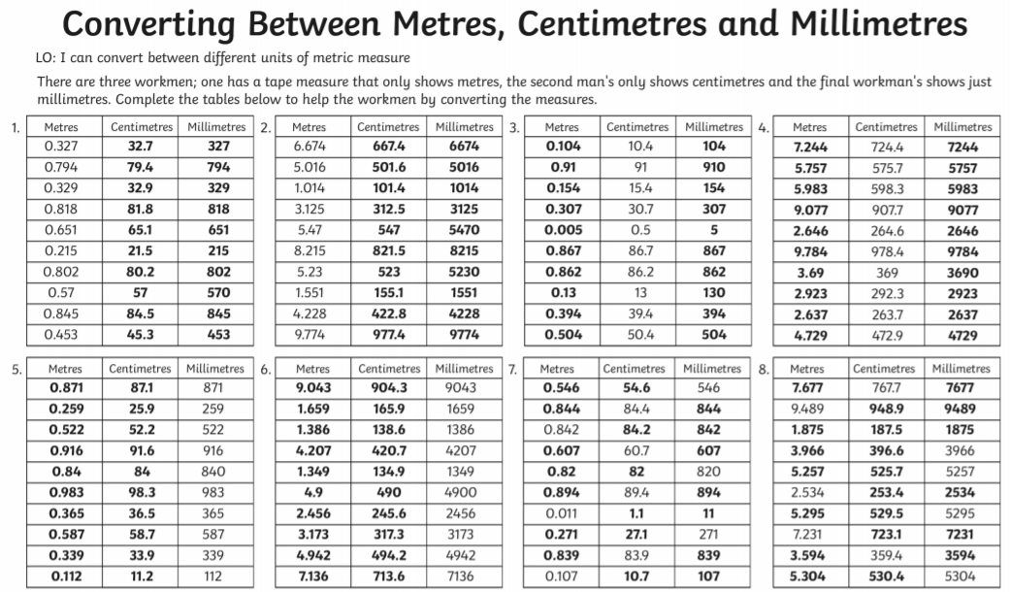**Friday**