**Summer 2 Week 1 mini-project**

**Queen Elizabeth II was crowned on 2nd June 1953. This week we’re going to be researching a bit about this historic event.**

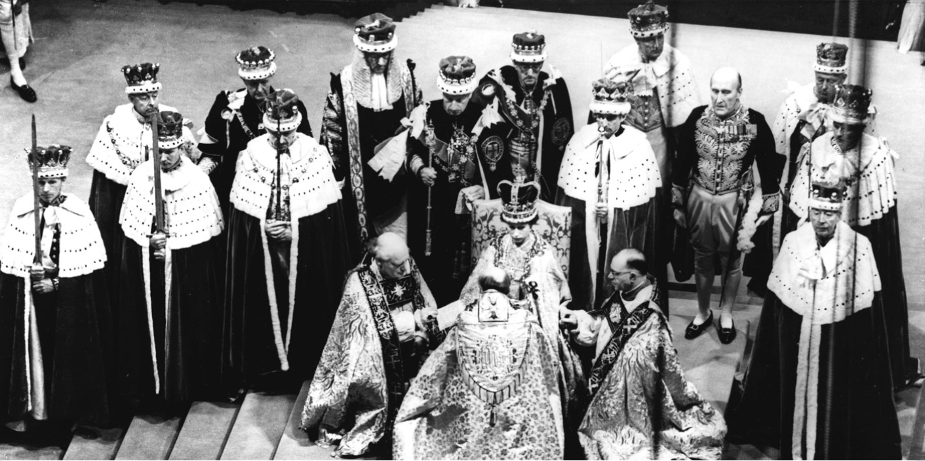

Task 1:

Read through the powerpoint, and answer the following questions.

1. Where does the coronation of a British monarch take place? ________________________________
2. Whose coronation was the first to be photographed? ______________________________________
3. Who was the first monarch to be crowned at Westminster Abbey? ___________________________
4. Who leads the ceremony? ______________________________________
5. What is the monarch handed during the ceremony? _______________________________________
6. What is Queen Victoria’s coronation known for? __________________________________________
7. What was special about Queen Elizabeth II’s coronation? ___________________________________
8. How many guests attended the coronation of Queen Elizabeth II? ____________________________
9. What well known chicken dish was created for the banquet of Queen Elizabeth II’s coronation? ___________________
10. What piece of music has been performed at every coronation since 1727? _________________________________________________________________________________

If you want to hear the coronation music – Handel’s ‘Zadok the Priest’ – you can listen to it here.

<https://www.youtube.com/watch?v=MiXgOQ9_-RI>

Do you recognise it? It is one of Ms Wiles’ favourite pieces of music.

For more interesting facts, you can look here:

<https://www.royal.uk/50-facts-about-queens-coronation-0>

Task 2:

Have a look at the following design. Does it look familiar? You’ve probably seen it on different buildings and objects without really thinking about it.

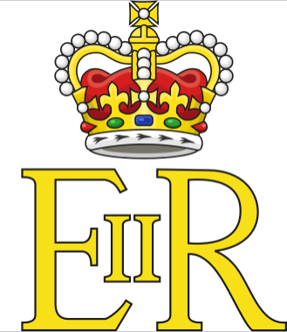

This is the Royal Cypher of Queen Elizabeth II.

A royal cypher is a [monogram](https://en.wikipedia.org/wiki/Monogram)-like device of a country's reigning [sovereign](https://en.wikipedia.org/wiki/Monarch), typically consisting of the initials of the monarch's name and title, sometimes interwoven and often surmounted by a crown. In the system used by various [Commonwealth realms](https://en.wikipedia.org/wiki/Commonwealth_realm), the title is often abbreviated to R for *Rex* or *Regina* ([Latin](https://en.wikipedia.org/wiki/Latin) for *king* and *queen*).

Your task is to design your own cypher.

Use your initials to create a cypher that suits you and your personality. As well as thinking about the font and the colours, think about whether you want a picture to top your initials, like the crown the Queen Elizabeth has.

Queen Elizabeth II’s cypher is quite plain. Other royals have more intricate cyphers, which you can use for inspiration:

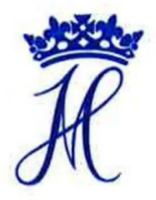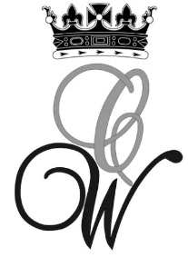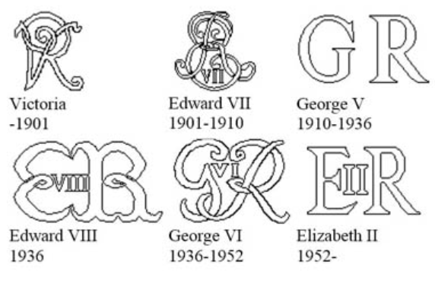

Prince Harry and Meghan

Prince William and Kate

Task 3:

Your task is to use your knowledge of ICT programmes such as Publisher or Powerpoint to create an information poster about the Coronation of Elizabeth II.

You can use the Present app in the j2office tab on the j2e platform.