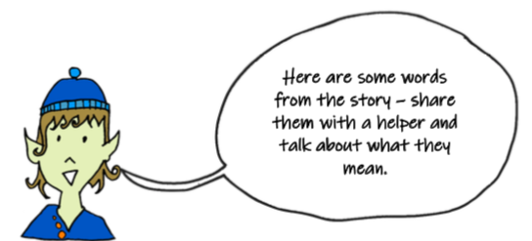

Can you think of and write down four things that are shiny?
Can you think of and write down four things that are soft?

Can you think of and write down four things that are sharp?
Sharp
Something. that is sharp usually has a pointy end and can or make holes in things easily.
Shiny
Something that is shiny is very bright. You can see your face in a shiny surface
Soft
Something that is soft feels nice to touch. It is not rough or hard.

