



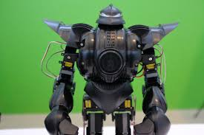



If you had a robot!

What would your robot look like?
What would it be able to do?

Can you think about and write what you would like your robot to do for you:
Think about:
How could you ask it to help you and your family and friends?
What kind of jobs might it be able to do, in your bedroom, in the living room, in the garden, perhaps even at school?

You can then draw your robot.

