**Answers**

**Monday:**

**Think Together**



Isla’s method:

Area of the garden = 5m x 6m = 30m2

Area with vegetables:

Bottom left triangle = 1m x 1m ÷ 2 = 0.5m2

Bottom right triangle = 5m x 1m ÷ 2 = 2.5m2

Top left triangle = 3m x 4m ÷ 2 = 6m2

Top right triangle = 3m x 4m ÷ 2 = 6m2

Total areas with vegetables = 0.5 + 2.5 + 6 + 6 = 15m2

Area of the garden – areas with vegetables = 30m2 – 15m2 = 15m2

Mo’s method:

Area of top flowerbed = 4m x 6m ÷ 2 = 12m2

Area of bottom flowerbed = 6m x 1m ÷ 2 = 3m2

Total area of flowerbeds = 12m2 + 3m2 = 15m2

2. Area of the floor = 120cm x 60cm = 7200cm2
3. Area of one tile = 30cm x 30cm ÷ 2 = 450cm2
4. Number of triangle tiles = 7200 ÷ 450 = 16

2. The area of the path = Area of whole garden – area of the grass

Whole garden = 7m x 6.5m = 45.5m2

Grass = 5m x 4.5m = 22.5m2

45.5m2 – 22.5m2 = 23m2

1. There is enough room on the grass for Toshi’s tent.

**Tuesday**

**Think Together**

1. Each rectangle has a perimeter of 30cm

1. The octagon must have a perimeter of 72cm

72cm ÷ 6 = 12cm

The length of one side of the hexagon = 12cm

1. The unshaded shape has sides that are equivalent to a width of 9cm and a height of 5cm.

9cm + 9cm + 5cm + 5cm = 28cm

1. If the rope is 48m long, the length of the adjacent sides of the rectangle must add to 24m.

The area will be largest when the two numbers are as big as possible. As we know that he land is rectangular, both sides cannot be the same or this would make a square. So the largest two whole numbers that add to 24 are 11 and 13.

11m x 13m = 143m2 so the greatest area is 143m2.

**Wednesday**

**Think Together**

1)

a) 8cm3

b) 11cm3

c) 28cm3

2)

a) Volume = 2 x 5 x 2

= 10 x 2

= 20cm3

The volume of the cuboid is 20cm3

b) Volume = 4 x 3 x 2

= 12 x 2

= 24

The volume of the cuboid is 24cm3

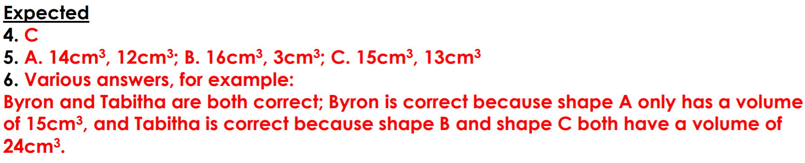**Worksheet**

**Thursday**

**Think Together**

2. 4 x 3 x 3

= 12 x 3

= 36cm3

1. 5 x 5 x 2

= 25 x 2

= 50cm3

1. 3 x 4 x 10

= 12 x 10

= 120cm3

**Worksheet**

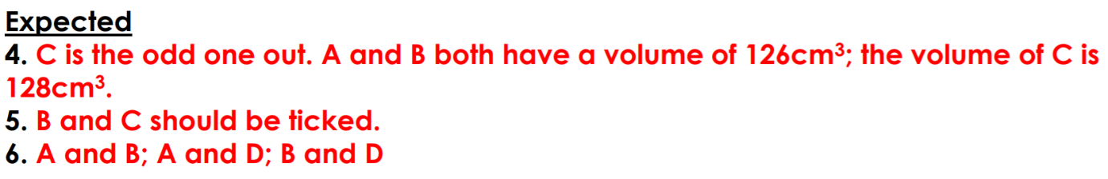

**Friday**

**End of unit test**

1. **A**
2. **D**
3. **B**
4. **B**
5. **32m x 10m ÷ 2 = 160m2**

**160 x £2 = £320**