Friday – 3D shape Shadows
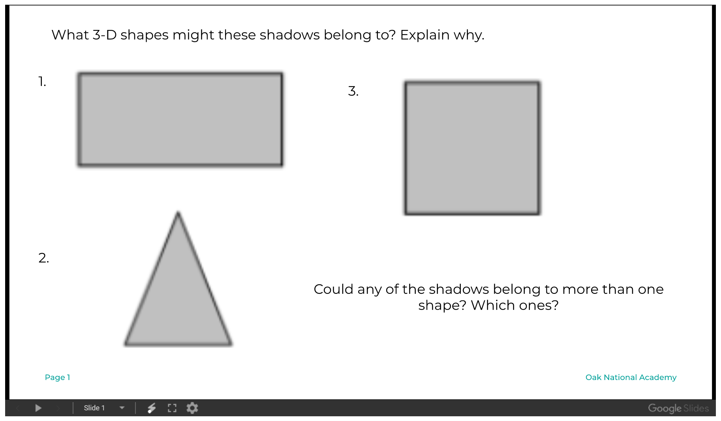
Write your Answers below:

