Monday – Shape Riddles
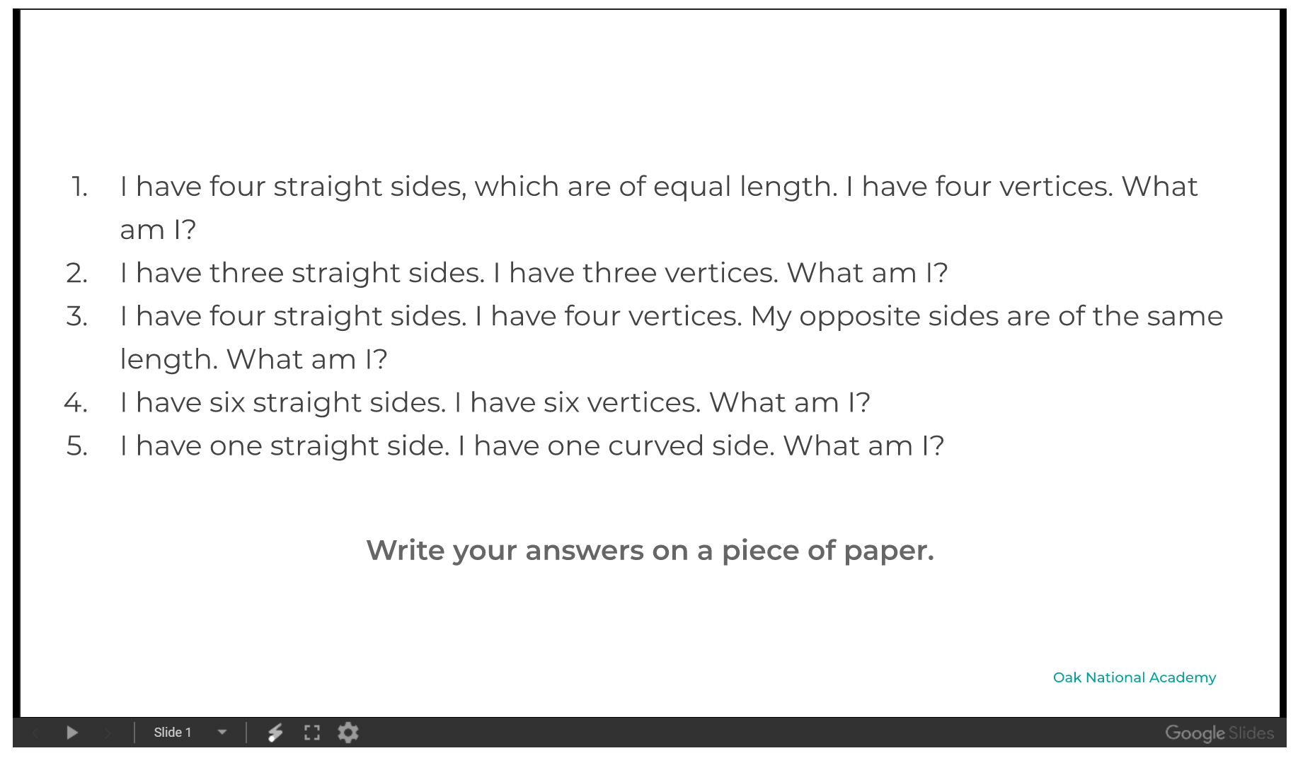
Write your Answers below:

