Thursday – Guess the shape
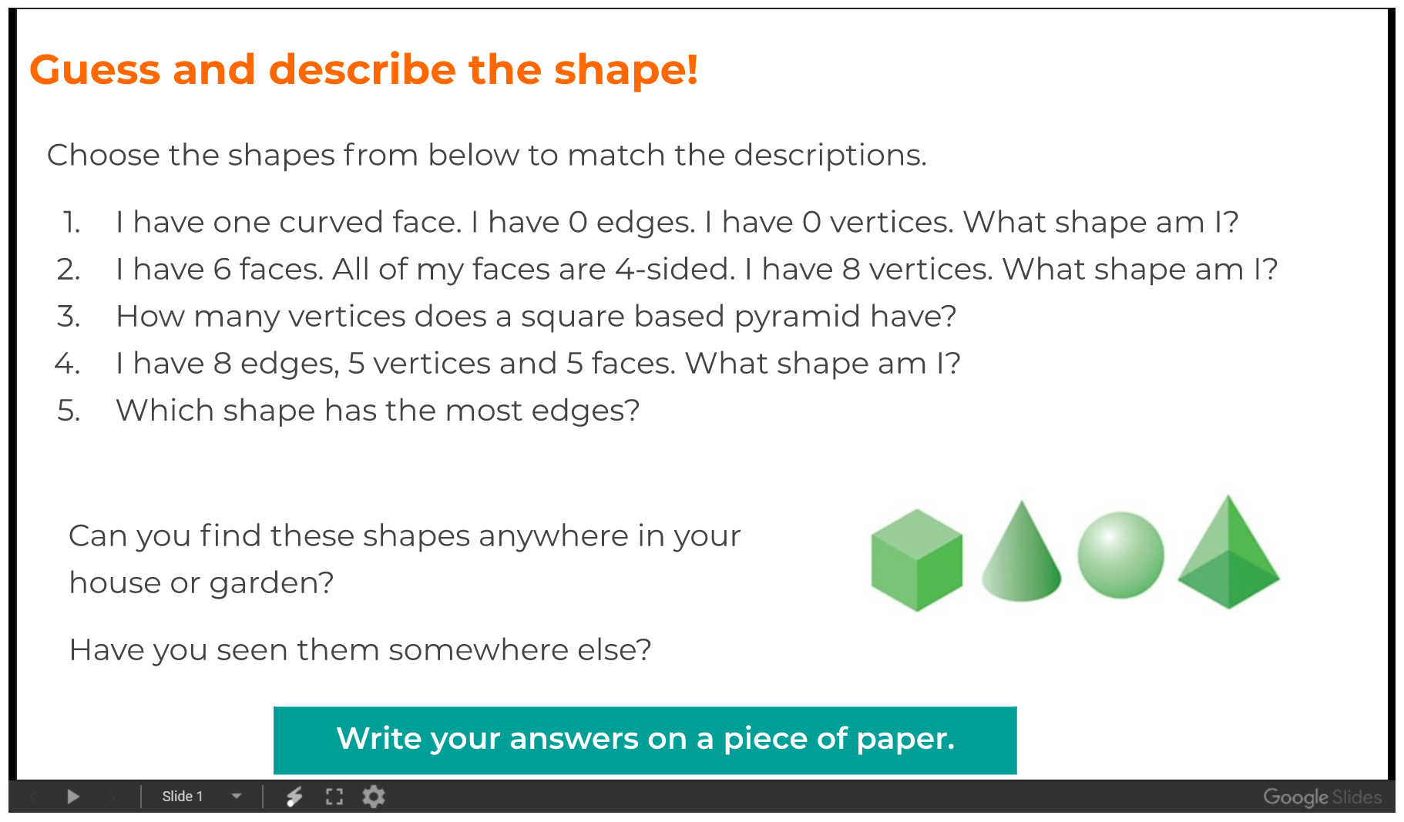
Write your Answers below:

