Here are some Summer Fruits. Can you colour in the correct amount looking carefully at the half and quarter signs.
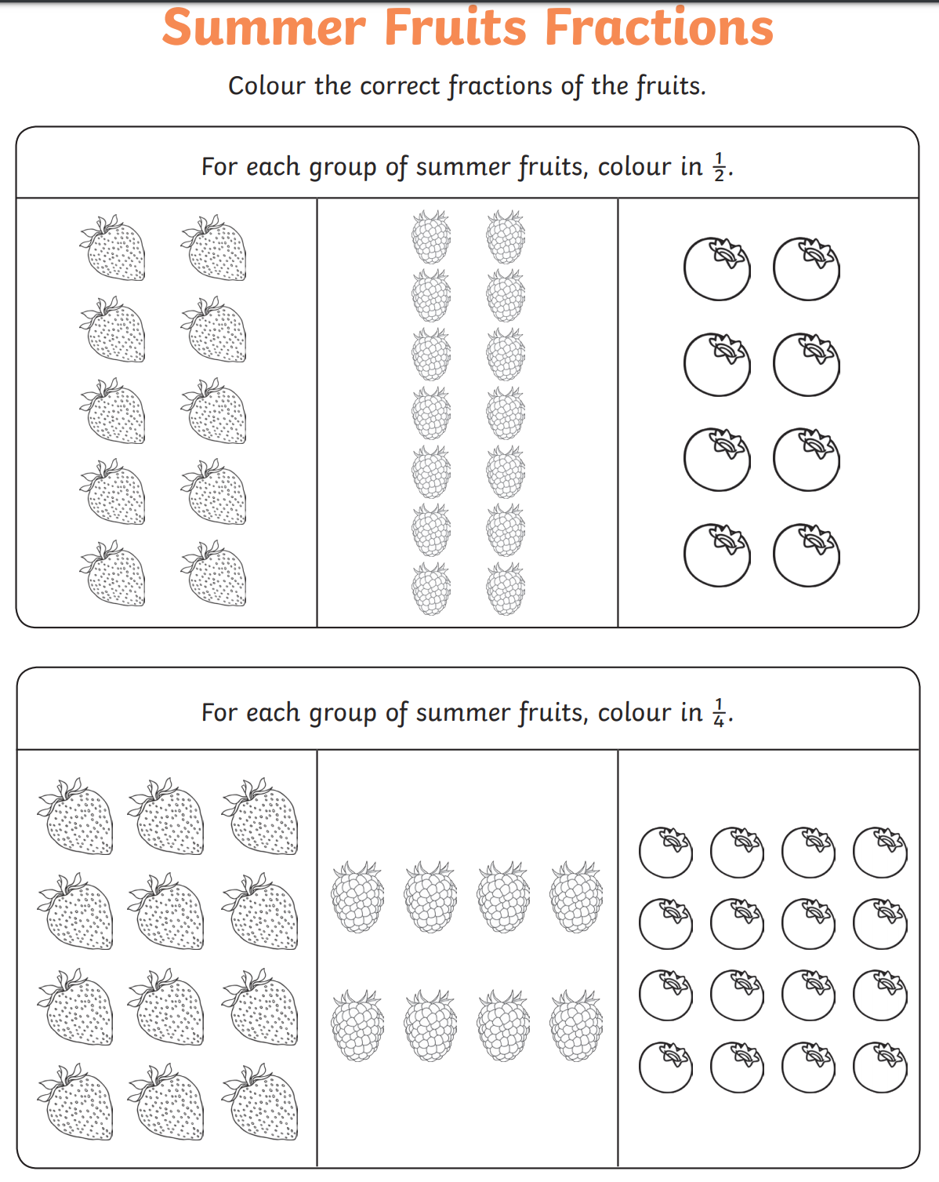
If you can’t print this document, you can copy and draw the fruits and then colour in half or a quarter.

