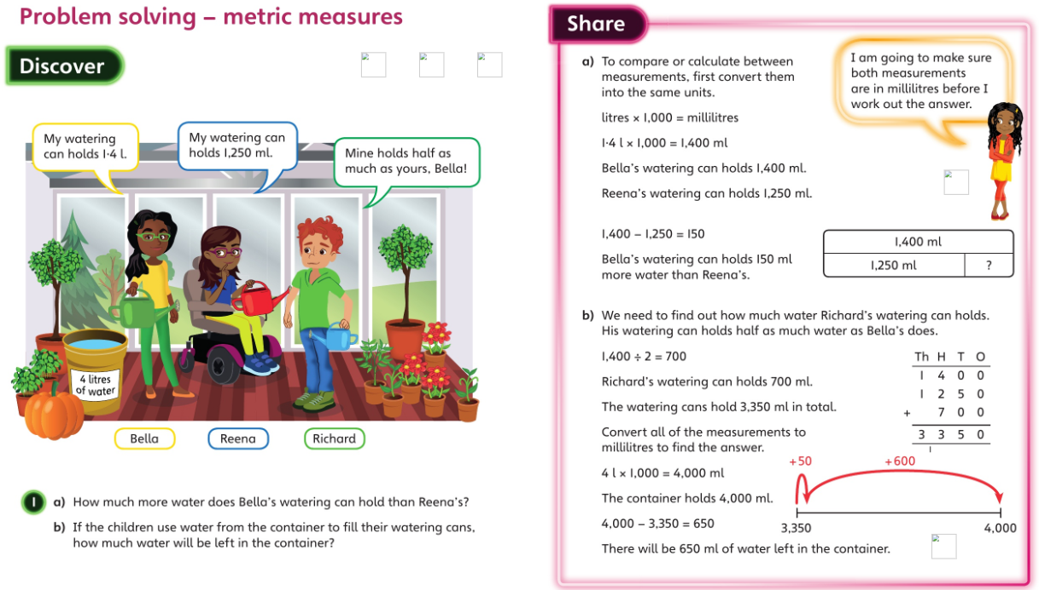**Wednesday**

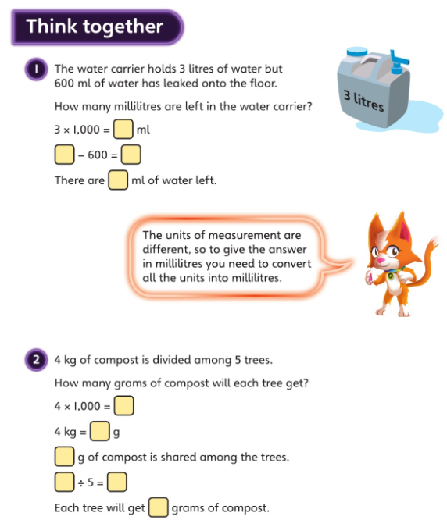

**_____ ÷ 5 = _____**

**_____g**

**___g**

**_____ - 600 = _____**

**____ml**

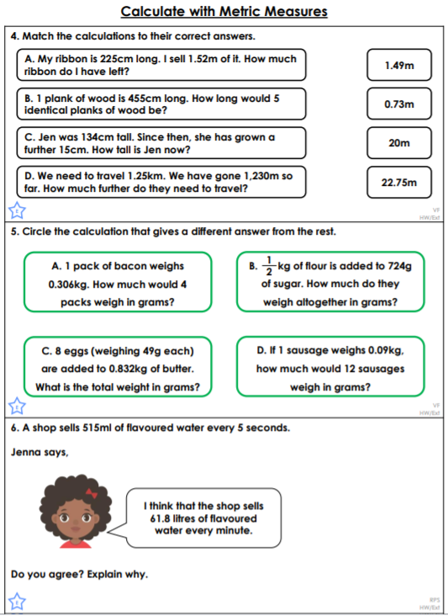

**Identify the calculation that gives a different answer from the rest.**