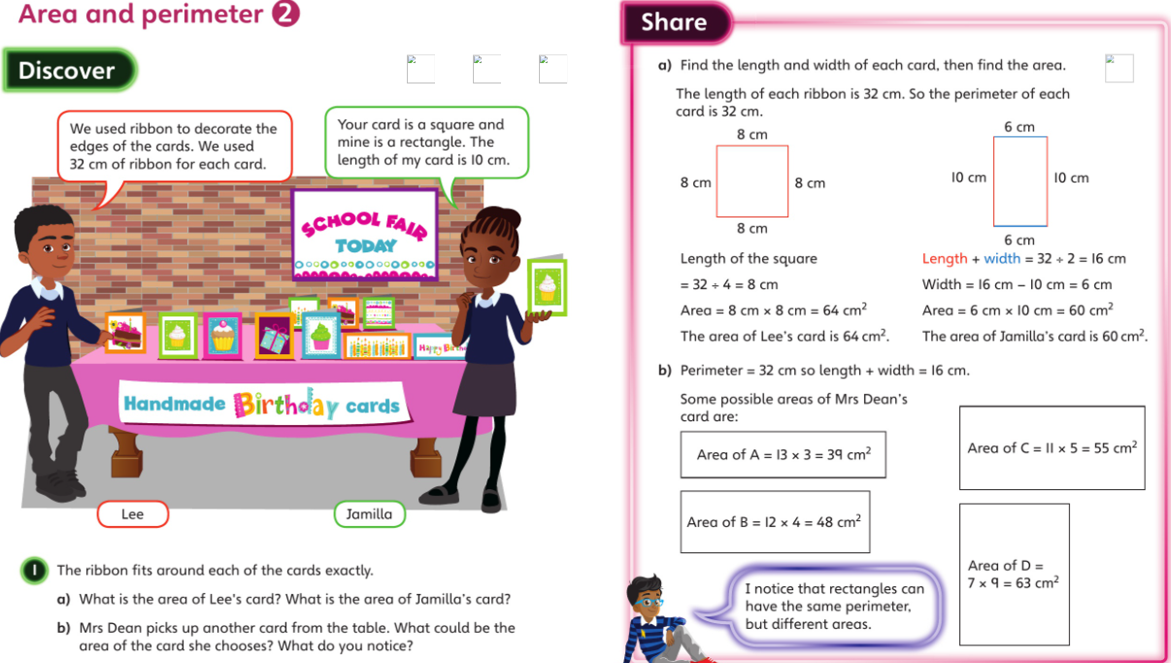**Monday**

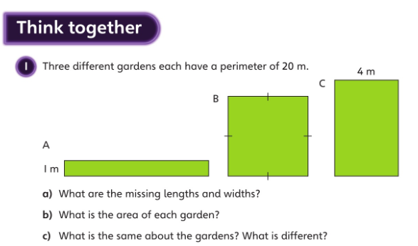

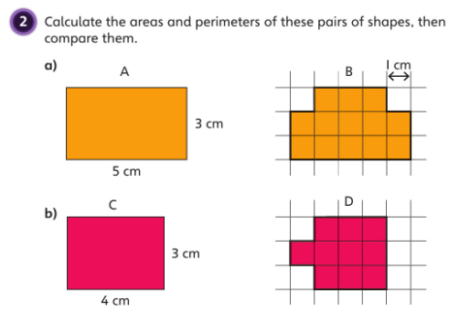

Compare A and B:

Compare C and D:

A:

Area =

Perimeter =

C:

Area =

Perimeter =

D:

Area =

Perimeter =

B:

Area =

Perimeter =

c)

Shape A:

a)

b)

Shape B:

a)

b)

Shape C:

a)

b)

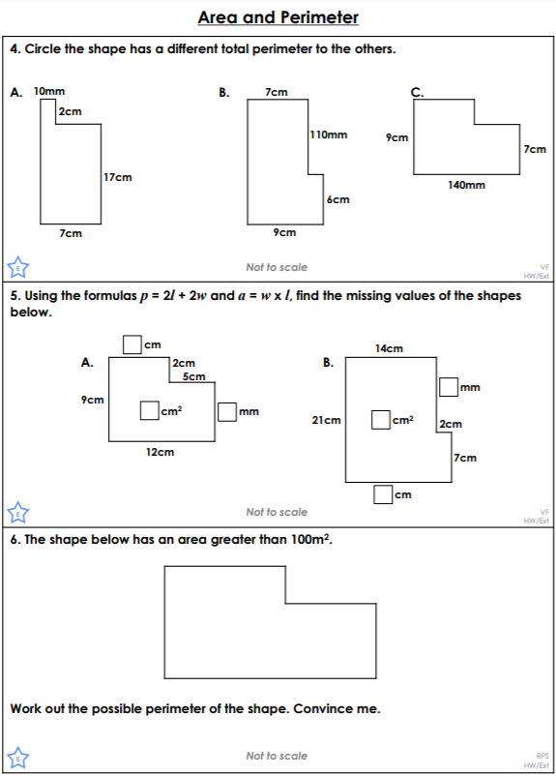



**5. Find the missing values in the shapes:**

**Identify the shape that has a different total perimeter.**