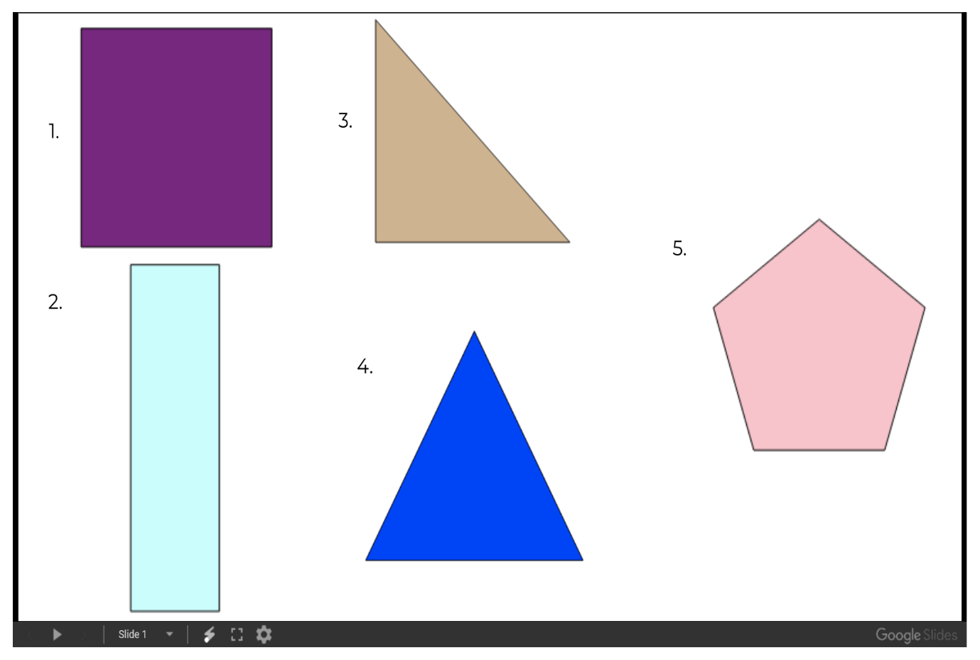
Wednesday – Can you find the lines of symmetry in these shapes? Can a shape have more than one?
Write your Answers below:

