**Answers**

**Monday:**

**Think Together**

c) The perimeter of the gardens are the same, but the areas and the lengths and widths of the sides are all different.

Shape C:

a) Length 4m, width 6m

b) area 24m2

Shape A:

a) length 9m, width 1m

b) area 9m2

Shape B:

a) length 5m, width 5m

b) area 25m2



Compare A and B: The perimeters are the same, but the areas are different.

Compare C and D: The perimeters are the same but the areas are different.

D:

Area = 10cm2

Perimeter = 14cm

C:

Area = 12cm2

Perimeter = 14cm

B:

Area = 13cm2

Perimeter = 16cm

A:

Area = 15cm2

Perimeter = 16cm

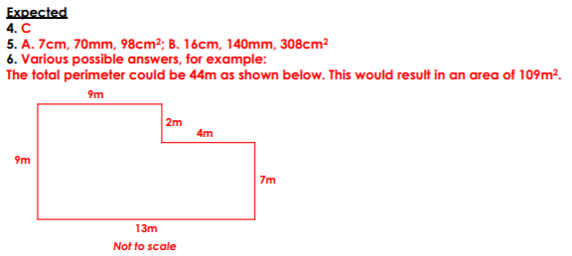**Worksheet**

**Tuesday**

**Tuesday**

**Think Together**

2. 12cm2
3. 12.5cm2
5. 3cm2
6. 3cm2

**Worksheet**

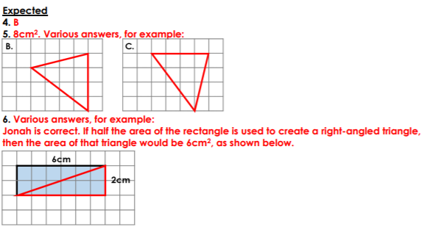

**Wednesday**

**Think Together**

1)

a) Area of rectangle = 3cm x 6cm = 18cm2

Area of triangle = 18cm ÷ 2 = 9cm2

b) Area of rectangle = 2cm x 2cm = 4cm2

Area of triangle = 4cm2 ÷ 2 = 2cm2

c) Area of rectangle = 4cm x 11cm = 44cm2

Area of triangle = 44cm2 ÷ 2 = 22cm2

2)

a) 8cm2

b) 5cm2

c) 7cm2

d) 22cm2

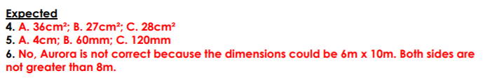**Worksheet**

**Thursday**

**Think Together**

2. 8 x 2 ÷ 2

8cm2

1. 3 x 6 ÷ 2

9cm2

1. 4 x 11 ÷ 2

22cm2

**Worksheet**

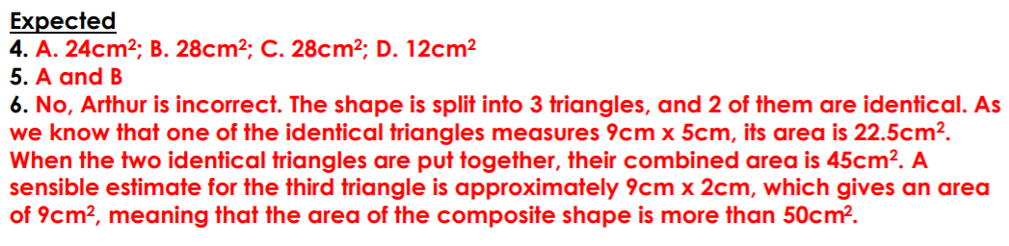

**Friday**

**Think Together**

2. Area of parallelogram A
3. Area of the parallelogram = area of the rectangle with

Width 6cm and length 5cm

6cm x 5cm = 30cm2

Area = 30cm2

1. Area = base x height

Area = 6cm x 5cm

Area = 30cm2

1. Area of parallelogram B
2. Area = 4cm x 2cm

Area = 8cm2

1. Area = 4cm x 2cm

Area = 8cm2

1. Area of parallelogram C
2. Area = 3cm x 2cm

Area = 6cm2

1. Area = 3cm x 2cm

Area = 6cm2

