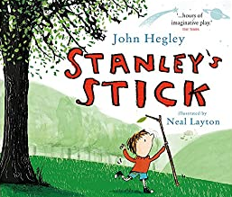

Where is Stanley? What is he doing? What do you think this story will be about? What do you think Stanley will do with the stick? How do you think he is feeling? How do you know? Write these down underneath the image.

