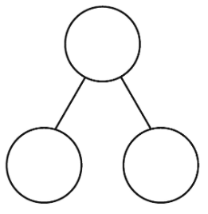
Example

10
10
10
4
6
10
6 + 4 =10

________+________=

________+________=

________+________=

