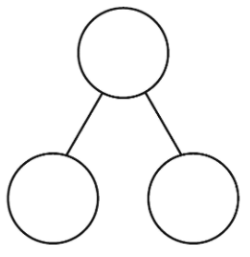
Example

10
10
10
4
6
10

