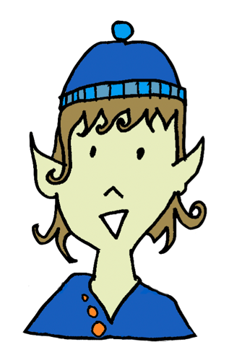
Poem

If I Had Wings
If I had wings, I would touch the frail fingertips of clouds.
If I had wings, I would taste
a chunk of the sun, as hot as peppered curry.
If I had wings, I would listen to the cloud’s soft breath.
If I had wings I would smell the scent of raindrops.
If I had wings, I would gaze
at the people who cling to the earth’s crust.
If I had wings, I would dream of swimming the deserts and walking the seas.

