**RE – Sikhism – lesson 3**

This week we’re going to be learning about the Sikh’s place of worship – the Gurdwara and the Langar..

Watch this video to learn more about the Gurdwara.

<https://www.bbc.co.uk/teach/class-clips-video/religious-studies-ks2-the-gurdwara/z4qc8xs>

This video is narrated by Simran, who describes what happens at the Gurdwara and the many symbols of respect they show when they are there. These include: taking off your shoes, washing your hands, covering your head, sitting down on the floor to eat, expressing equality through sharing food without taking notice of differences of gender, wealth, age or any other differences.

Simran explains that every Gurdwara has a kitchen - the famous ‘Langar’ - where anyone can eat; so long as they are willing to eat with everyone else. This helps to feed the poor and needy – and to challenge the wealthy and proud. Some Sikhs even take langar onto the streets as well to feed the homeless.

Simran has a go at helping to make food for everyone, but her skills are not perfect yet. Still, it is the intention that matters!

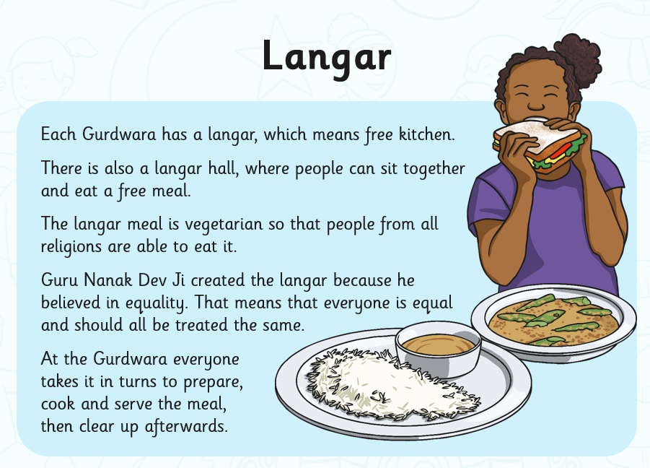

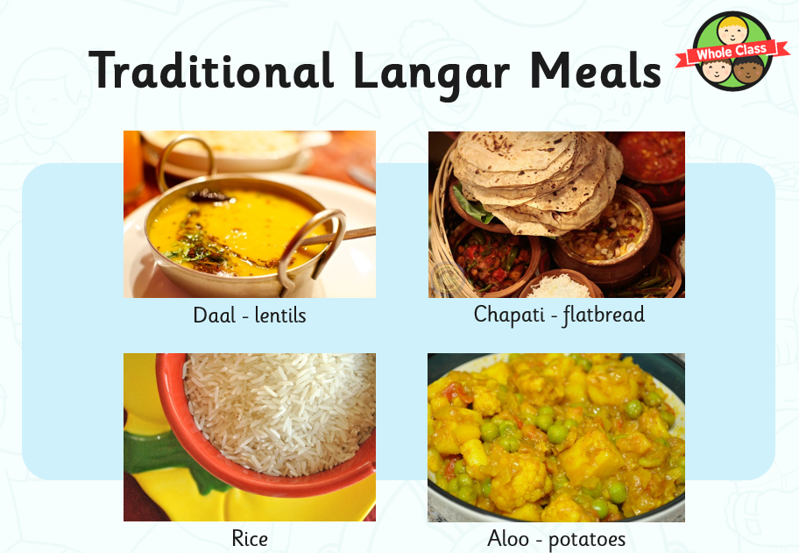

Your task is to design a meal that you would like to serve to others in the community. Think carefully about what you ingredients you should use to ensure that everyone would be able to eat it. Can you explain why you made this choice?

**My meal is:**