Read the story, talk together about the story and then answer these questions.
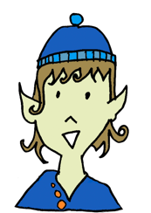

What parts of the story did you like the most?
I liked ...

Did anything about the story surprise you?

I was surprised by...


Do you have any questions?

I was wondering ...

