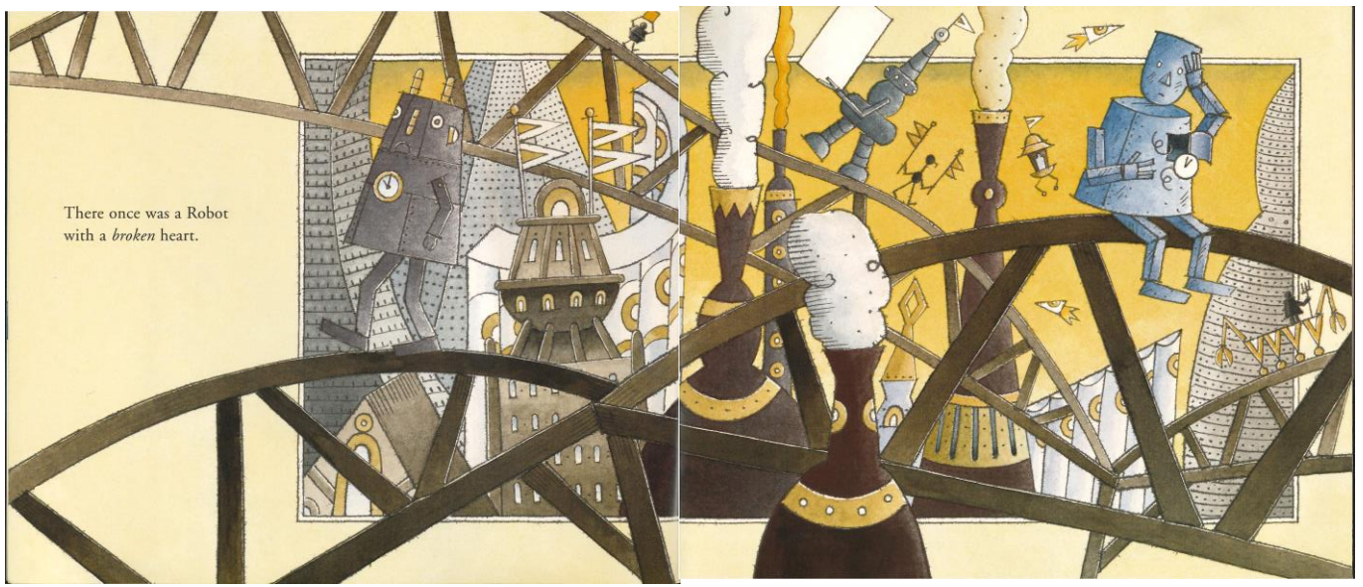
Read aloud the words on the page above and spend time looking at the illustration.
Can you explain, using clues from the text…
What you think is happening here?

Who do you think the story is about?

