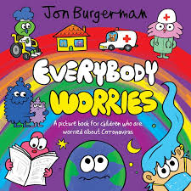
Read the e-book called Everybody worries with an
Adult. Use the link below.
https://en.calameo.com/read/000777721945cfe5bb9cc?authid=Xu9pcOzU3TQx
Sharing worries and feelings can you make you feel better and it is important to always talk about how you are feeling.
If you find that tricky, you can also draw any worries you may have, give them a name and then share them with an adult.

What did you like about the book?

Did you find it helpful?

