Read the poem ‘If I had wings’.
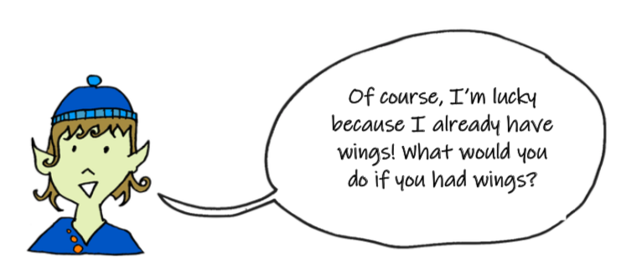
Pipperty Skycap wants to know what you would do if you had wings?

If I Had Wings
If I had wings, I would touch

If I had wings, I would taste

If I had wings, I would listen

If I had wings, I would smell

If I had wings, I would gaze

If I had wings, I would dream

