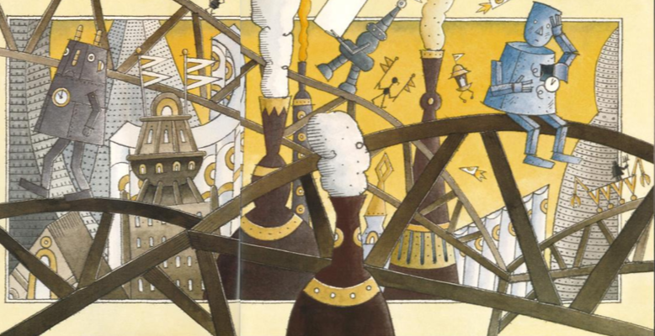

Have another look at this image. Today you are going to think about the setting of this story. This means, where the story takes place.

Where do you think this story is taking place and why do you think that?

What words or phrases would you use to describe this place?

What do you think it would be like to be there?

