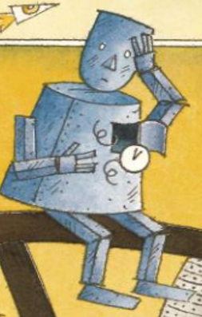
Focus in on the character of the robot

What does it look like?

How do you think the robot feels about his broken heart?
How do you know?

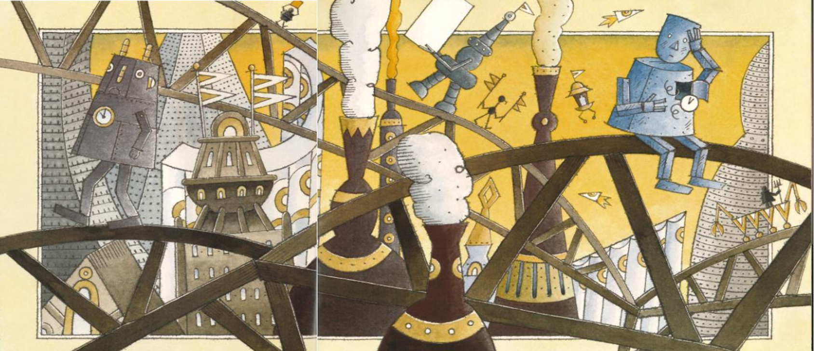
Look at the other robots in this picture.

What are they doing?

Do you think they have noticed the robot with the broken heart?

Why do you think they are walking in the opposite direction?

