Sayeeda, the pirate princess
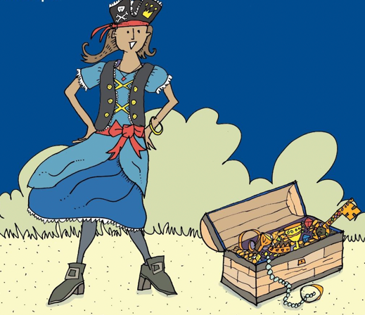
Once upon a time, there was a pirate princess called Sayeeda who lived on a pirate galleon with her pirate family. Sayeeda loved to spend her days looking at all the beautiful treasure the pirates had stolen as they sailed the seven seas. There were golden brooches, pearl rings and ruby bracelets but, most of all, she loved to open her very own treasure box.
One breezy, sunny morning, Sayeeda sat on deck with the treasure box in her hands. “Don’t open your treasure box on deck,” warned her father. “It’s a breezy morning and the galleon might hit a big wave and your treasure will roll out.” Sayeeda didn’t listen.
Carefully, very carefully, she lifted the lid and took out a beautiful jewelled key, her favourite. She lifted it to her neck but.... “Whoosh...sh...sh...sh!” The galleon rocked to and fro, fro and to and a huge wave swept over the deck. “Whoosh...sh...sh...sh!” Sayeeda held on tightly to the rail but the jewelled key slid from her hands. Down, down, down it sank into the deep, dark sea. Sayeeda wept.
Luckily, a dolphin passed by and heard Sayeeda weeping. “Jump onto my back and hold my fin,” he said. “We’ll dive down and try to find it. “So, they swooped and they swooped through the water. Unluckily, there was no sign of the jewelled key. Sayeeda climbed back onto the pirate galleon and wept again.
Next, a whale passed by and heard Sayeeda weeping. “Climb onto my head in front of my blow hole,” she said. “We’ll glide across the sea and look down through the clear ocean water and try to find it.” So, they swished and swashed gently across the water. Unluckily, there was no sign of the jewelled key. Sayeeda climbed back onto the pirate galleon and wept even more.
Finally, a seagull landed on the deck beside Sayeeda. “Jump onto my back and hold my wings,” he said, “We’ll fly across the sea and try to find it.” So, they flew high through the gentle breeze and all the seagulls’ friends joined them. They flew and they flew until they came to a beach and Sayeeeda jumped off the seagull’s back. She took a few steps across the sand and ... there in front of her was a jewelled key. Her key. “Oh, thank you,” said Sayeeda to the seagull. Together, they flew back to the pirate galleon. Sayeeda locked the key safely in her treasure box. Then she took the box to her cabin and locked it away in her cupboard. She remembered her father’s warning. Never again, would she open her treasure box on the deck.
