Year 6 Light Assessment

1. Name 3 light sources:

* ___________________________________
* ___________________________________
* ___________________________________

1. Explain how we see the moon at night

______________________________________________________________________________________________________________________

1. Fill in the gap in this sentence:

*Light travels in a ___________ line.*

1. Draw two arrows to show how the eye sees the apple:

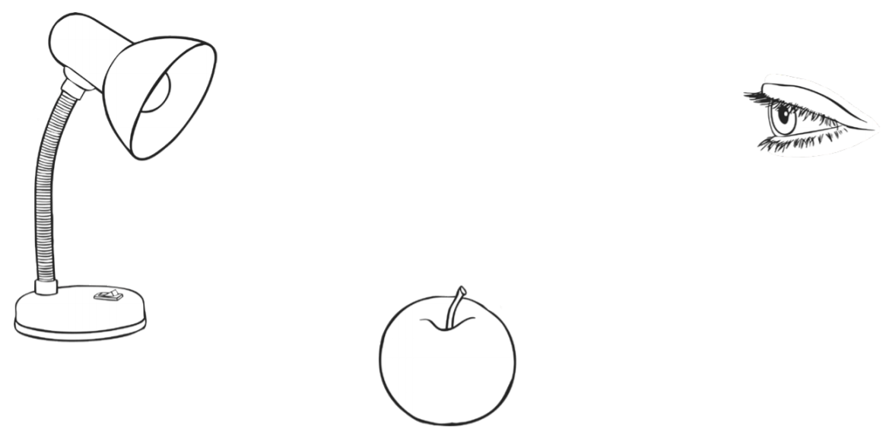

1. Draw two lines to show how the person sees the bird through the telescope:

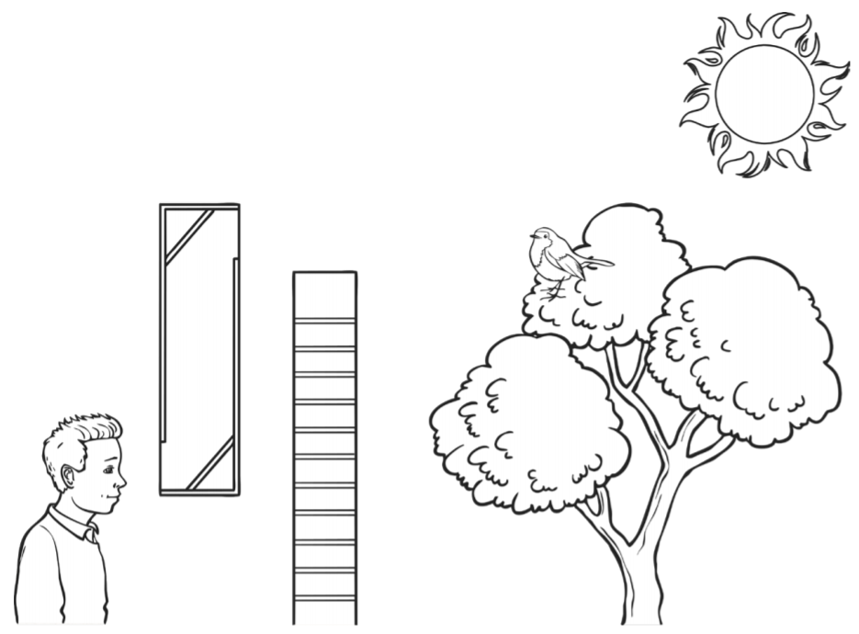

1. Describe what happens when you put an opaque object in front of a light source:

______________________________________________________________________________________________________________________

1. Describe how the size of a shadow changes as you move an opaque object further away from the light source:

___________________________________________________________

___________________________________________________________

1. Describe how the size of a shadow changes as you move an opaque object closer to the light source:

______________________________________________________________________________________________________________________

1. Write true or false for these statements:

Light travels in straight lines ………………………………..TRUE/FALSE

The moon is a light source …………………………………..TRUE/FALSE

Light can travel through space …………………………….TRUE/FALSE

Stars shine because they reflect the sun’s light……TRUE/FALSE

1. 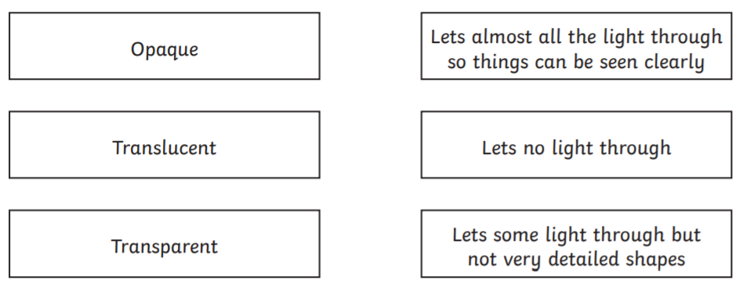Join the words to their meanings: