**Spanish – Summer 2 Week 1**

Watch here for an explanation of how to say numbers to 30 in Spanish

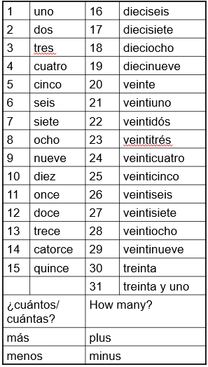<https://www.youtube.com/watch?v=K6llt8GyqLA> Counting 21 – 30 with Basho & Friends

**CHALLENGE!**

Look at number 31.

Using this as a guide, what do you think the Spanish for 32 is?

___________________________

Can you continue?

33 = _______________________

34 = _______________________

35 = _______________________

36 = _______________________

37 = _______________________

38 = _______________________

39 = _______________________

40 = cuarenta

1. diez + diez = ***veinte***
2. veinte + seis =
3. doce + doce =
4. treinta + uno =
5. diez + diez + diez =
6. veinte + ocho =
7. treinta – tres =
8. treinta – cinco =
9. treinta – ocho =
10. make up your own!

