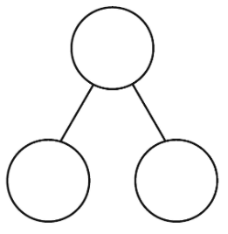
Example

2

18

16
10
20
20
1
19
20

