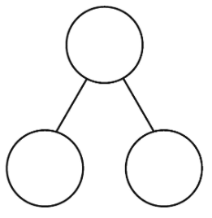
Example –The missing number is 8.

9

6

7
10
10
10
8
2
10

