**Election Glossary!**

|  |  |
| --- | --- |
| **Word** | **Meaning** |
| Campaign | When a person tries to persuade other people to vote for them. |
| Election | When people vote for a new Prime Minister. |
| Landslide | When a party wins a vote by a huge amount. |
| Parliament | The place where the government meets to make decisions on the country. |
| Prime Minister | The person in charge of a country. |
| Seat | Earning seats in parliament means that you have as many supporters as possible within your government. |

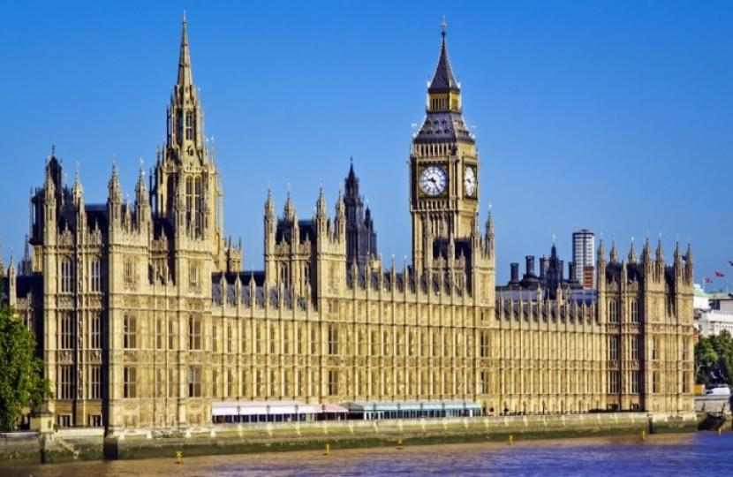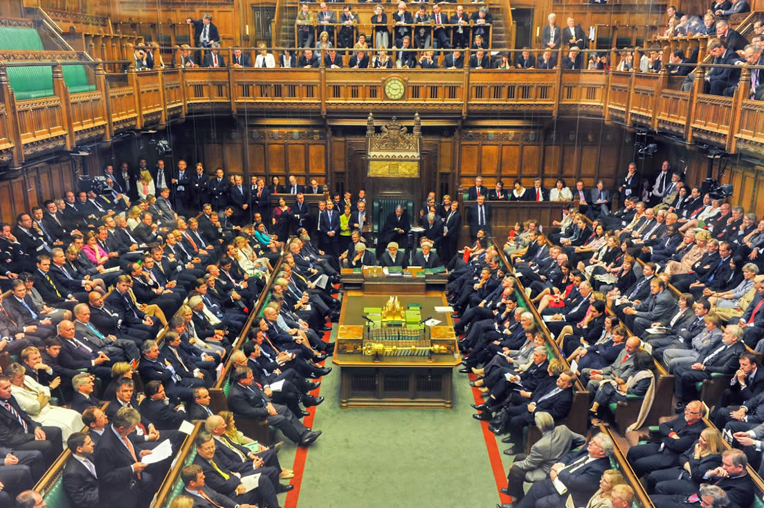

Seats in parliament UK Houses of Parliament

