**Thursday planning task**

As you know from yesterday’s activity, there are some countries in the world where citizens do not have as much freedom as others. On the night of April 17th, 1989, Chinese students began a protest at a place called Tiananmen Square (which is in Beijing, the capital of China). They wanted to live in a country that had: more freedom of speech; more freedom to learn about topics other than what the government chose for them and more freedom for the media to report on news stories not just chosen by the government.

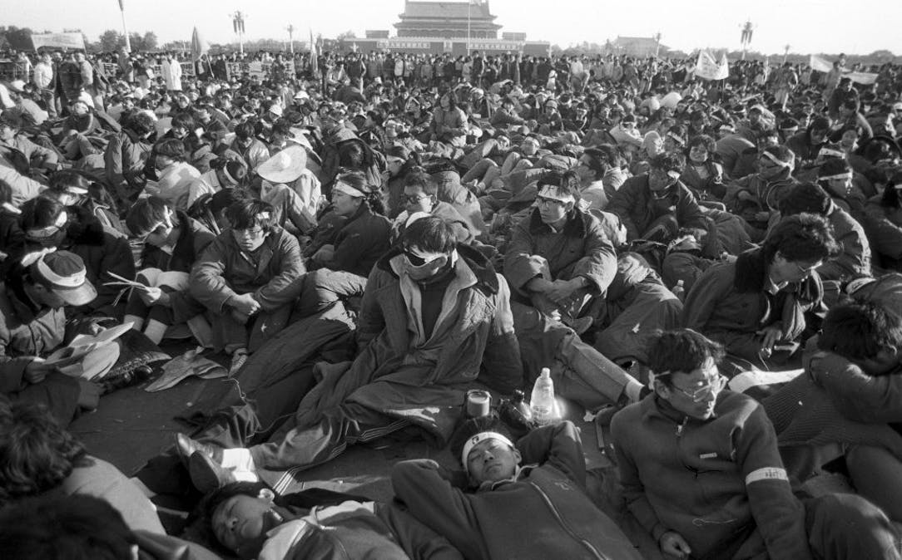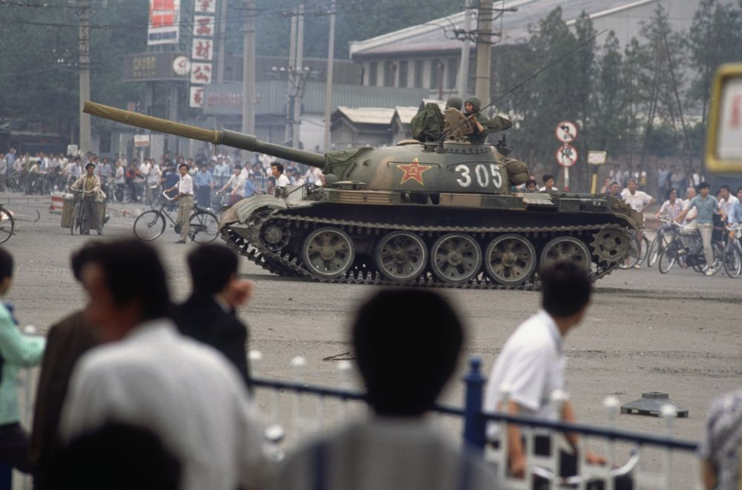These protests lasted until June of 1989. Because protesting is not allowed in China, the government sent in the army and the police to regain control of the hundreds of thousands of people who were protesting in Tiananmen Square. Approximately 10,000 people were arrested and many died (although the official number of deaths has never really been reported). Here are some photographs of the incident:

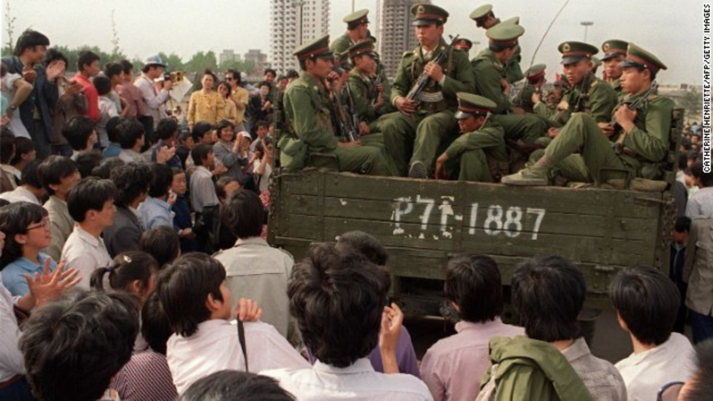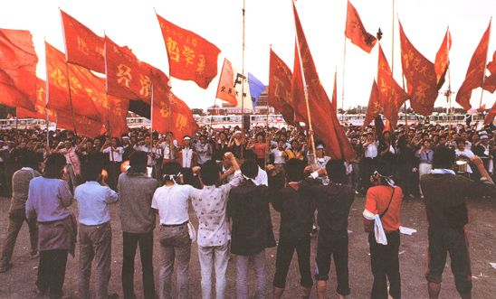

**One of the most famous photographs which was shown around the world by news channels was the photograph on the next page…**

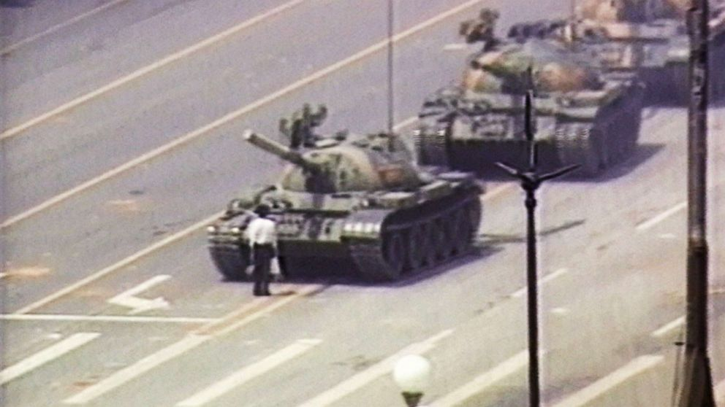

This man felt so strongly about Chinese people having more freedom that he was prepared to stand in front of an oncoming tank. This was putting his life at risk because the Chinese army and police were not afraid of shooting anyone who they deemed to be doing the wrong thing (not to mention the fact that the tank could have run him over).

Tomorrow, you are going to write a diary entry in role as this man. To get you started, have a think about the boxes below and start putting your thoughts in place.

|  |  |
| --- | --- |
| Why did you feel so strongly that you stood in front of the tank? What do you want to change in your country based on this protest? |  |
| Emotions: Which words describe how you felt whilst you were standing in front of the tank? |  |
| How could you show how you feel rather than telling the reader? |  |
| Which rhetorical questions were going through your mind when you were in front of the tank? |  |