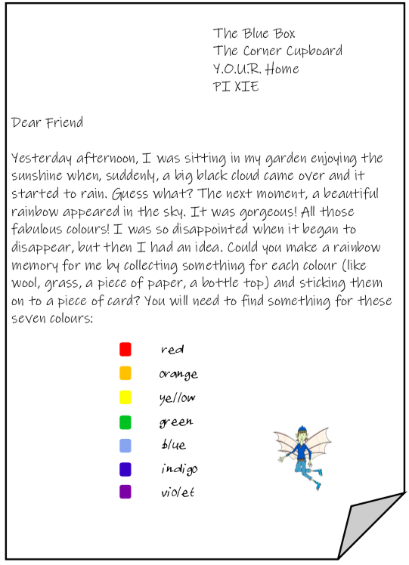
Don’t forget to take a picture of your rainbow treasure hunt and upload it!
Can you then write about your rainbow treasure hunt? Remember to use time connectives such as first, then, next, after that, finally. Explain everything that you found and where you found it!

