BECOME A KINDNESS DETECTIVE.

Over the next week, look out for acts of kindness or help happening around you. Make note of each act of kindness that you see during a whole week. Share your chart when it is full. If you do something kind, you can also add it on there. Use the one below or make your own.
Here is an example:

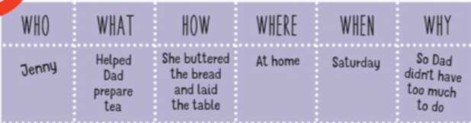

This kindness chart belongs to:

WHO | WHAT | HOW | WHERE | WHEN | WHY

