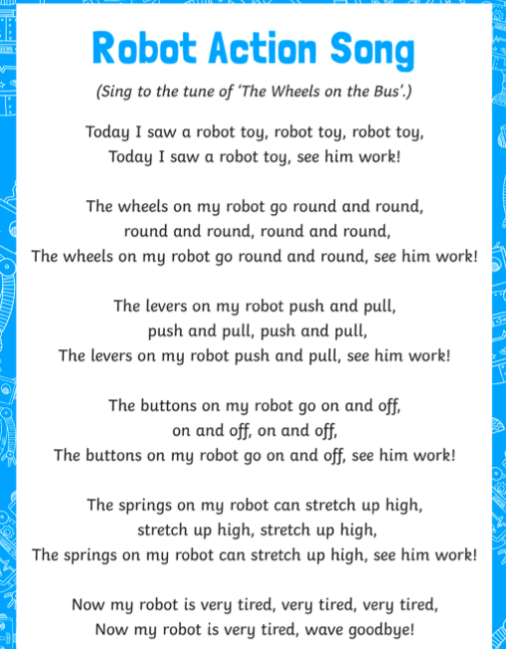

Can you read these ‘Robot Action song’ Lyrics.
Can you make up some actions to go with the words?
Can you perform these to your family?

