**Week 2 – Bringing the right attitude**

Its really important that you approach new challenges, like starting a new school, with the right attitude. A growth mindset will mean you have the right attitude to make a positive start at your new school. It will also help you think in a way that is more flexible, creative and helps you solve problems, so it’s a good mindset to adopt throughout your life in every situation!

**Task 1:** What is your attitude towards school? Think carefully and complete the table. There is no right or wrong, just be honest:

|  |  |  |  |
| --- | --- | --- | --- |
|  | **Yes** | **No** | **Sometimes** |
| I find it easy to stay motivated to do my work, even when the task is difficult. |  |  |  |
| I always engage with the lesson and stay focused on my work. |  |  |  |
| I enjoy working on new tasks and challenges that I haven’t tried before. |  |  |  |
| I enjoy learning and look forward to lessons. |  |  |  |
| I find inspiration in other peoples’ success stories. |  |  |  |
| I push myself to keep going when the work is challenging. |  |  |  |
| I take responsibility when I make a mistake and try to fix things. |  |  |  |
| I see mistakes as an opportunity to learn and make sure I don’t do things wrong next time. |  |  |  |
| I like receiving feedback on my work because it helps me to improve. |  |  |  |
| I find learning new things exciting and interesting. |  |  |  |

If you answered mainly ‘yes’, then you are well on your way to developing a the positive mindset that will help you adapt and develop the skills that will help you throughout your school and working life.

If you answered mainly ‘no’ or ‘sometimes’, then the next activities will be particularly important in helping you develop a growth mindset and establish a positive attitude towards school.

**People with a growth mindset:**

* **Embrace new challenges and see constructive feedback as a good way of improving.**
* **Are resilient and resourceful in the face of difficulty.**
* **View knockbacks and mistakes as part of the journey, not the end of it.**

**Task 2:** Sometimes we are a better friend to other people than we are to ourselves. Imagine these two people are your friends. What advice or reassurance would you give to them?

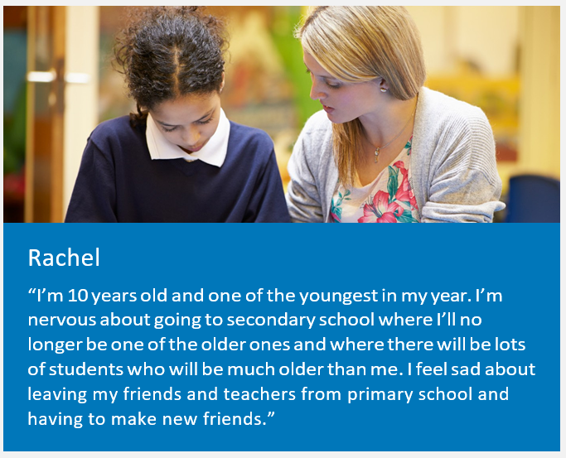

My advice to Rachel would be….

My advice to Fahim would be….

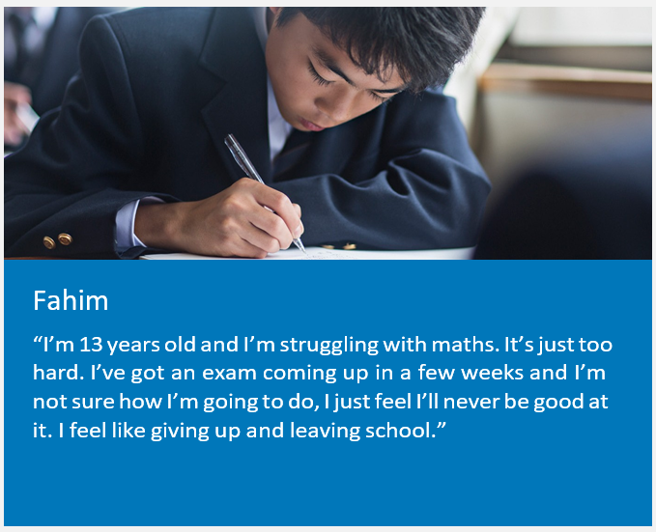

**Task 3:** Now you’ve had a chance to think about what advice you might give to a friend that is worried, remember that you should be a good friend to yourself too.

Below are some common thoughts that we all have when things are difficult. Rephrase these thoughts so that you can turn these challenges around into a positive learning experience. One has been done for you as an example.

|  |  |
| --- | --- |
| Fixed mindset | Growth mindset |
| I can’t do this | I need to practice this more. |
| I give up |  |
| This is too hard |  |
| My friends are better at this than me |  |
| I’m no good at this |  |
| I already know how to do that well enough |  |
| This isn’t a strength of mine |  |
| I will never understand this |  |
| My friend is smarter than me |  |
| Other people find this easy but I don’t |  |

**Remember the power of YET! No one is an expert the first time they do anything. Becoming good at anything takes time, hard work and practice. Try adding yet to the end of your negative thoughts. If you can’t do something now, it doesn’t mean you’ll never be able to do it, you just can’t do it YET!**