**Week 3 – How is secondary school different?**

One of the most obvious differences between Primary and Secondary school is that instead of having one teacher who teaches you everything, you have several teachers who teach you one subject each. This means that you will have to take responsibility for making sure that you’re in the right class at the right time with the right equipment.

You will know where you’re supposed to be and what lessons you have each day from reading your timetable. This will show the subject, room and probably have the initials of the teacher on it for each lesson of each day. Although every school will have a different way of organising their timetables, it may look something like this:

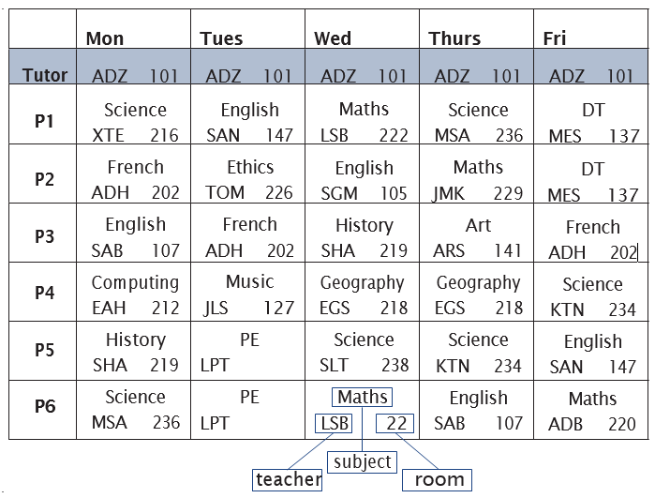

If this was your timetable:

1. What lesson would you have in period 3 on Thursday? _______________________________
2. What day would you need to take your PE kit into school? ____________________________
3. Which books would you have to take to school on Thursday?

______________________________________________________________________________________________________________________________________________________

**Try to prepare your bag the night before for the next day so that you don’t have to rush in the morning.**

Task 1: Some days you might need specific equipment for a lesson like PE, and you will need to take the right books for the lessons you have each day. However, there are a lot of other things that you will need every day.

You will probably need to take:

* Your timetable
* Any homework that is due to be handed in
* Your planner or homework diary
* A reading book
* A pencil case with pen, pencil, ruler, sharpener, rubber and calculator.
* A water bottle
* A packed lunch or your lunch card/money to use at the school canteen
* Your bus pass
* A bag to carry everything
* Your house keys if you’re coming home alone

Use the space below to make a list of anything that you don’t have and will need to get

Task 2 – lots of children start travelling by themselves to school when they start secondary school, or find that their journey is longer than before or means they need to use public transport. This can be a little scary so if you can, try and practice the journey with a trusted adult before the first day of school so that it feels a little more familiar.

Task 3 – It is important to be on time to school. Think about your morning routine and the things that you will need to do before you leave for school. Consider how long the journey will take and consult with bus or train timetables if necessary. Write out a schedule for school mornings to help you keep organised on track. Below is one to use as an example.

**Top tip: work backwards from the time you need to arrive at school.**

7.00 Get up, shower/wash, brush teeth, brush hair and get dressed

7.35 Make and eat breakfast

7.50 Check of my bag to make sure I have all the equipment that I need

7.55 Leave the house and walk to the bus stop on the main road

8.05 Get on the bus

8.20 Get off the bus and walk along the high street to the school

8.25 Arrive at school and meet with friends for a quick chat

8.35 School begins

My morning routine: