**Today, you have the opportunity to research two of China’s most famous sights, The Great Wall of China and the Terracotta Warriors**

**There are some questions below to start your research off if you are not sure.**

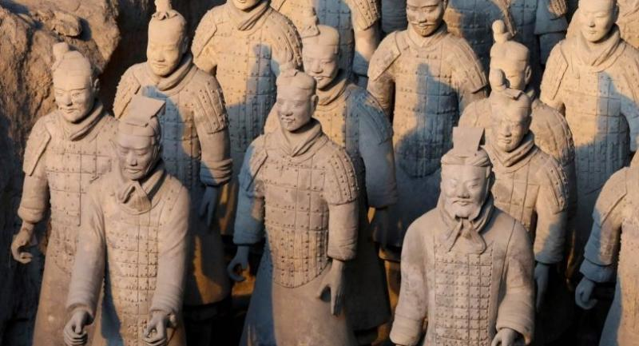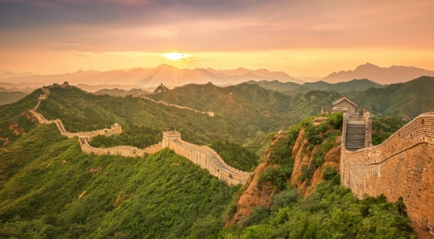

|  |  |
| --- | --- |
| **The Great Wall of China** | **The Terracotta Warriors** |
| *When was the Great Wall built? Why was it built? How many people did it take to build it? Which materials were used to build it? How far does the Great Wall stretch? Where does it begin and where does it end?* | *What are the terracotta warriors? How many warriors are there? Why were they created? Who wanted to have them created? How were they found and who found them?* |