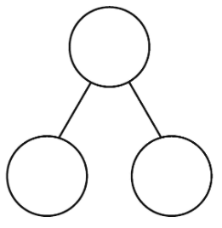
Example

20o
20
20
3
17
20
17 + 3 =20

________+________=

________+________=

________+________=

