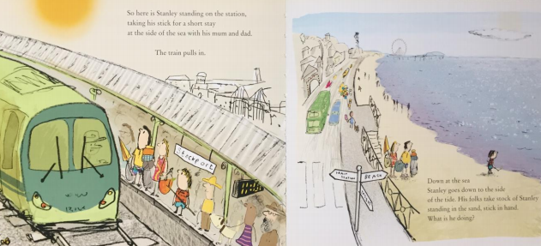
Where is Stanley? Where is he going on the train? Who is he with? What seaside objects have they taken with them? Why do you think Stanley has taken his stick with him? Read the first page together again.

