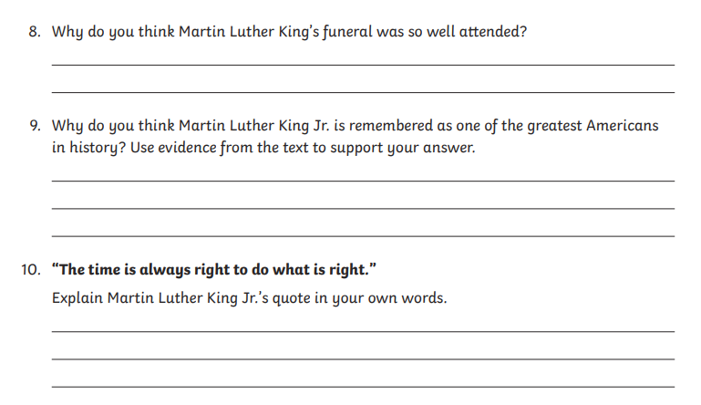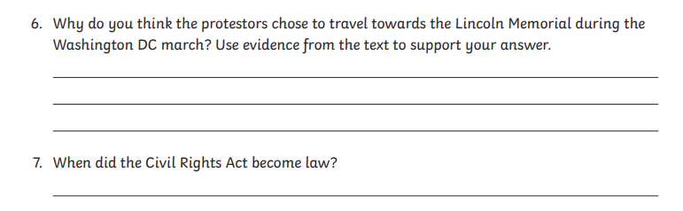**Tuesday questions – Martin Luther King**