**Monday toolkit task (there is a toolkit grid on the next page for you to fill in)**

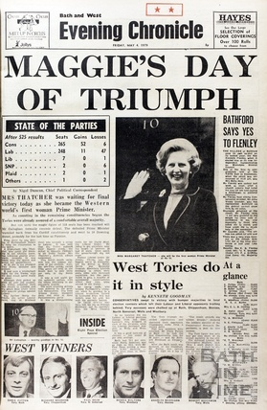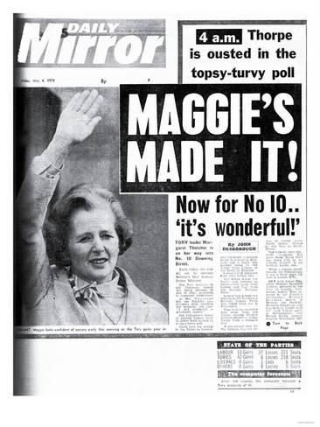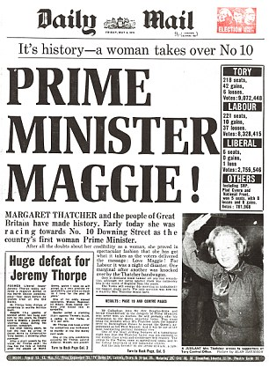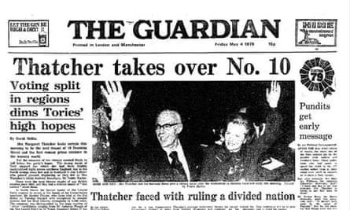

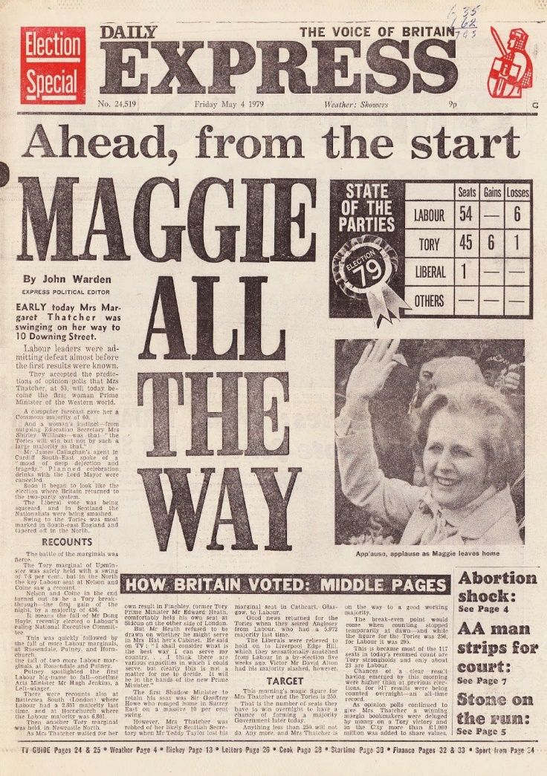

Toolkit: Which common features of a newspaper article can you see in each of these front pages? One feature has been included to start you off.

**Toolkit:**

|  |
| --- |
| Clear photographs of the person that the newspaper article is about. |
|  |
|  |
|  |
|  |