**How would you feel if you lived in a world without…**

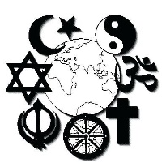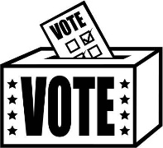

**…learning about different religions in school**

**…social media (including Google and YouTube)**

**…being able to vote for your leader in an election**

**…freedom of speech (not being able to say your opinions on things – particularly about the government)**

*e.g. I would constantly feel scared in case I said my opinion and a police officer of government official overheard me. I could get thrown into jail. Or worse…*

**…being able to play a video game which has violence in**

**…being able to read any book that you choose (the government monitor which books are allowed)**