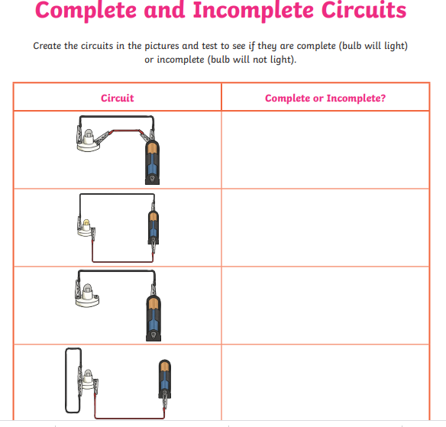**Week 10 Science**

What is the difference between complete and incomplete circuits?