Home Learning Timetable Year 2- Summer 2 - Week 2 - Week beginning – 08.06.2020
Monday | Tuesday | Wednesday | Thursday | Friday
Take 10
Complete 10 minutes of daily physical activity. This could be skipping, running, dancing or see joe wicks cards for ideas. OR Join Joe Wicks on YouTube for daily 30 minute home PE sessions at 9AM (see link below)
Reading – prediction  Have a look at the front cover and title of the new book we will be looking at this week. ‘The robot and the bluebird’ Can you make a prediction. What do you think this book about? | Reading - inference  Explore the Image and read the sentence.  Can you answer the questions about the image. | Reading - Characters  Focus in on the character of the robot. What does it look like? How do you think the robot feels about his broken heart? How do you know? L | Reading - Setting  Look at the image again, Now think about where this story might be taking place? Where do you think this is happening? What words or phrases would you use to describe this place? What do you think it would be like to be there? Discuss with an adult. | Reading  Listen to the story – ‘The robot and the bluebird’  Watch David Lucas talking about the ideas behind The Robot and the Bluebird here, and retelling the story: https://www.youtube.com/watch?v=Mhzpf9bJ-gM.
Maths Focus this week is SHAPE :
To help support your child’s learning of Shape there are 5 lessons on the Oak Academy website. Each day the site will provide a lesson about shape. It will have a video to explain the learning and will provide some activities. Children can also complete a little quiz at the end of the session.
This week we will be using the section FACE, SHAPE and PATTERNS – starting with lesson 1
https://www.thenational.academy/online-classroom/subjects/#subjects
Maths  Lesson 1 - To identify shapes by the number of vertices and sides  See activity sheet | Maths  Lesson 2 - To identify right angles in shapes  See activity sheet | Maths  Lesson 3 - To recognise lines of symmetry within 2-D shapes  See activity sheet | Maths  Lesson 4 - To name and describe 3-D shapes  See activity sheet | Maths  Lesson 5 - To identify 2-D shapes on the surfaces of 3-D shapes  See activity sheet
Literacy –  Write a recount about your weekend? Did you do anything different/new?  Remember to use -  time connectives,  adjectives, feelings. | Literacy – Think about if you had a robot.  What would your robot look like? What would it be able to do?  Think about what you would like the robot to do for you:  how could you ask it to help you and your family and friends? What kind of jobs might it be able to do, in your bedroom, in the living room, in the garden, perhaps even at school? | Literacy – How can we help the robot?  Look again at the robot from the storty and think about how it might be feeling. What do you think could be done to help the robot?  Is there anything the other robots in the illustration could do?  If you could program these robots, what would you tell them to say or do? | Literacy  Look at the setting - what might you see, hear, smell? How do you think it would feel to be there?  SENSES GRID | Literacy  After making/drawing your robot. Can you write about what you have used and why. Think about what each part is for.
Daily Phonic Lesson: -  Year 1 – Summer Lesson 11  u-e – tube  https://www.youtube.com/watch?v=aW-zdYN_z90&list=PLuGr6z2H2KNGObda6B-T36vJlZYN06lOh&index=24&t=0s | Daily Phonic Lesson: -  Year 1 – Summer Lesson 12  e – we  https://www.youtube.com/watch?v=bnASDAef03U&list=PLuGr6z2H2KNGObda6B-T36vJlZYN06lOh&index=22 | Daily Phonic Lesson: -  Year 1 – Summer Lesson 13  aw – saw  https://www.youtube.com/watch?v=6Em7ix0mPdc&list=PLuGr6z2H2KNGObda6B-T36vJlZYN06lOh&index=20 | Daily Phonic Lesson: -  Year 1 – Summer Lesson 14  ir - bird  https://www.youtube.com/watch?v=-jb0cqvNEr0&list=PLuGr6z2H2KNGObda6B-T36vJlZYN06lOh&index=18 | Daily Phonic Lesson: -  Year 1 – Summer Lesson 15  Ou - cloud  https://www.youtube.com/watch?v=9mPiMevwOUU&list=PLuGr6z2H2KNGObda6B-T36vJlZYN06lOh&index=16
Topic  Shape hunt – what shapes can you find. You can take photos, draw them. Can you identify their vertices and sides. | Topic  Can you read the ‘Robot Action song’ Lyrics.  Can you make up some actions to go with the words? Can you perform these to your family? If you can, film this for your teacher to see! | Topic  ART – Draw a picture where both sides are the same. Think about a butterfly and how it is symmetrical. It has identical sides if you fold it in half. What could you draw with a line of symmetry? | Topic– CREATE IT!  Create your robot – Use different junk modelling. Which 2D/3D shapes will you use. | Topic  PURPLE MASH - design a robot menu on purple mash.  Think carefully about what a robot might eat. 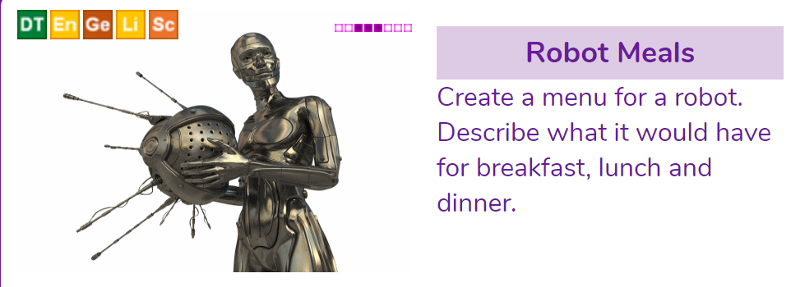
Spelling  For your spellings this week we are going to introduce to you four new ‘wow words’ that can be used to describe a robot. You will then learn the meanings and spellings of these words and hopefully use them at some point in your writing over the week.  Mechanical – Used to describe something that involves a machine.  Rigid – unable to bend, it has to be forced out of shape. You could use this word to describe how a robot moves.  Obedient – If you always do what are you are told.  Genius – Extremely smart or talented. | Handwriting  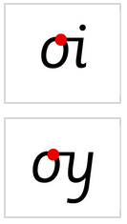 | Spelling Have another look at this week’s ‘wow words’. Practise writing each word across your page. Can you put each word into a sentence to check your understanding? | Handwriting   | Spelling  Have another look at this week’s ‘wow words’. Can you write down another word for each that means the same and then a word that means the opposite.  E.g  Obedient – respectful - uncontrollable.
Story time
Ask your parent/ carer/ sibling to read to you at bedtime. OR read a book yourself for 10- 20 minutes before you go to sleep
Mindfulness
Enjoy a quiet session of mindfulness. Join gonoodle and select an activity. https://family.gonoodle.com/channels/flow

Links to websites
Maths:
Oak National Academy
https://www.thenational.academy/online-classroom/year-2#subjects
TT Rockstars
https://play.ttrockstars.com/auth
Use this to improve your multiplication.
All Other subjects
Purple mash – various activities to explore. Class teacher may also suggest an activity to complete on the timetable.
Twinkl - There are lots of additional support materials on this website for parents and children.
Think about all the subjects you find challenging, can you find some extra work to complete to support your learning. .
Science:
Explorify
https://explorify.wellcome.ac.uk/ - have a look and see if you can complete a fun science experiment
Woodland Trust
Activities for children if you are self-isolating
https://www.woodlandtrust.org.uk/blog/2020/03/kids-nature-activities-self-isolation/

DT – Food Tech
Some ideas for getting children involved with cooking
https://www.bbcgoodfood.com/recipes/category/family-kids

Joe Wicks – PE for kids
And just in case you’ve missed this. A daily session for children
https://www.thebodycoach.com/blog/pe-with-joe-1254.html

If you need any help with the work please email the school office office@keysmeadow.enfield.sch.uk
Your message will be forwarded and returned by the class team as soon as possible.

